**DECO2500 Individual Report**

**Low Fidelity Prototype Evaluation**

For the evaluation process of the low fidelity prototype multiple evaluation methods were used to determine how well the first iteration conceptual design fits with end users' mental models. The three evaluation methods used include the following:

* Design Walkthrough
* Technical Acceptance Model (TAM)
* Checking Questions

Each selected evaluation method followed a set of three predefined protocols (**REFERENCE APPENDIX**)and appropriate participant consent forms. For the purpose of constancy and dependencies of each method, the same 5 participants were used in this first evaluation process. The 5 participants ranged in diverse backgrounds with age, gender and educational level, such that the application targets an audience within the age range of 16 - 70 years old. The diversity of the participants is illustrated below in figure ??.

|  |  |  |  |  |
| --- | --- | --- | --- | --- |
| **Index Referral** | **Name** | **Age** | **Gender** | **Educational Background** |
| 1 | Shakuntala Nayak | 47 | Female | Masters, Business and Accounting |
| 2 | Arun Naik | 58 | Male | PHD Psychology |
| 3 | Nitin Naik | 17 | Male | HSC |
| 4 | Luke Peff | 19 | Male | TAFE Fitness, HSC |
| 5 | Kanishka Kapoor | 22 | Male | Electrical Engineering Honours |

**Low Fidelity Prototype Design Walkthrough**

How

The design walkthrough evaluation method was conducted via the video conferencing application ‘Zoom’. For the purpose of evaluating the effectiveness of the conceptual design. the participants were set five tasks to complete:

* Set up a Sleep Plan
* Create and Manage Goals and Achievements
* Notifications and Track Sleep Performance
* Using Community Page and Sleep Medical Report
* Settings

These tasks were stated to the participant as part of the Walkthrough Protocol (**REFERENCE APPENDIX**). For each task the participant was verbally notified of the instructions and given a chance to ask any clarification questions. The Low-Fidelity prototype was a paper model and screen shared via Zoom. To understand users' interactions with the system, the model was opened with ‘MS Paint’, and users instructed to left-click with a red paint-brush for any interaction within the paper application model. For each task the participants were asked specific sub-tasks to complete, and no help or guidance was given. At the end of each task, the participant was questioned about their actions and thought process, as well as any difficulties faced doing a certain task. At the end of the Walkthrough the participant was thanked for their time, and given the Technical Acceptance Model (TAM) survey to complete with the TAM protocol (**APPENDIX**)instructions also explained to them.

What Information and Why

The purpose of the Design Walkthrough was to observe end users interacting with the initial conceptual design. This included the interaction flow of what they found easy, hard, time taken, through processes and the number of actions required to accomplish a certain task.

This Walkthrough also assisted in understanding what features of the application work well, and what featured need further development in the conceptual design. The participants' additional questions at the end of each task provided details of what changes they would expect in the next iteration for a specific task.

Variations

During the Design Walkthrough interviews some variations were made to the method. This included additionally asking users what they thought could be done to better improve their interaction with the application during a task. This was done to gauge an immediate understanding of any shortcomings of features, instead of asking at the end of the task where the user might miss details of their experience. The other variation was assisting users recover from erroneous steps, participants that struggled for a lengthy time were given mynute guidance to ensure the Walkthrough could be finished within the timeframe.

Results

From the Design Walkthrough Protocol (**APPENDIX**), the summary of results is outlined in figure ????? below:

|  |  |  |  |  |  |
| --- | --- | --- | --- | --- | --- |
| **Task Number** | **Task Description** | **Average Time (minutes)** | **Average Taps** | **Difficulties and Negatives** | **Positives** |
| 1 | This included creating a sleep plan from the Home page and with users mock personal data and viewing the created sleep plan | 11.4 | 12.5 | Determining Which screen was the home page P[1,2,3,4]  Finding where to input personal data P[1,2]  Understanding what icon correlates to creating a sleep plan P[1,2,4]  Distinguishing Between Re-Evaluating and Creating a new Sleep Plan P[2] | Ability for a sleep plan to meet personal needs was a good addition P[2]  Wording for icons was simple and intuitive P[1,2,5]  Sleep Plan Page was found within 2 (s) P[1,2,3,4,5] |
| 2 | The second task was to create a life goal and view current achievements, then edit a current goal, starting from the home page. | 8.2 | 15.3 | Users didn’t see of forget to user Goal priority feature P[1,2,3,5]  Misunderstood life goals as sleep goals P[2]  Didn’t tap add after entering a goal P[2] | Navigating to Goals and Achievements was quick P[1,2,3,4,5]  Proposed an ordering feature instead of priority to drag current goals up and down P[2]  Agreed Goals were good for motivation to sleep well P[1,2,3,4,5]  Editing an existing goal was quick and easy P[1,3,4,5] |
| 3 | From the Homescreen locate the page for sleep performance for the last two weeks, state rating and current health risks. View notification alert from application. | 7.4 | 9.2 | Struggled to distinguish between expected and actual sleep P[1,2,3]  Could not locate health risks P[1]  Didn’t use scroll feature for both the graph and additional health risks P[1,2,3,4,5]  Notifications lacking icon P[3] | Sleep rating and health risks was good for simple understanding of sleep performance P[1,2,5]  Notifications of motivation was good P[1,2,3,4,5] |
| 4 | The next task was to locate community page, find latest thread, post a thread, find the medical report page, generate and save a medical sleep report for the last 20 days. | 13.6 | 18.7 | Participants didn’t understand the moderation feature for community page P[1,2,3,4,5]  Didn’t understand the concept of a thread P[1,2,3,4]  Didn’t find how to post own thread P[1,2,4] | All participants located pages with ease and understood the expanding list icon navigation bar P[1,2,3,4,5]  Having communities moderated by regions was a good idea for inclusivity and feeling comfortable P[2,5]  Process of generating a sleep report was quick and easy P[1,2,3,4,5]  Having a detailed medical report easily accessible and accurate was a good feature P[1,2,5] |
| 5 | The final task included finding the settings page from the homescreen, changing the language to French, using dark mode, disabling notification, changing privacy and sending feedback and viewing user documentation. | 6.8 | 10.1 | Participants were not aware of default privacy settings were and didn’t consent to this setting P[1,2,4,5]  Feedback entry field was difficult to use and send feedback P[1,2,4] | All participants quickly found settings page from home page P[1,2,3,4,5]  Language, Notification and user documentation sub tasks were completed quickly with no issues/errors P[1,2,3,4,5].  P[2] from a psychology background supported the inclusion of dark mode as good for reducing eye strain |

*Note P[x] refers to Participant(s) x*

Notes and Analysis

Significant notes and comments from the participants included a change of the design of the community page for adding a thread to be a simple button, “I think a simple add topic button would do” [1]. Another note was adding a page that users can accept and understand the privacy terms for the application, “I want to know what this default privacy is?”[2]. Adding a simple UI button and presenting a page to accept privacy default conditions were immediate quotes and observations of the participant.

From the Design Walkthrough first iteration evaluation it was evident that the low-fidelity prototype had both positive and negative interactions with the conceptual model. The features and designs that need to be developed in the conceptual model include the following:

* Creating Initial sleep plan - Have a dedicated page for both profile and creating a sleep plan
* Revise iconography and accompanying text for navigation and title
* Explain Goals and Achievements Feature - Possible Tutorial Feature
* Revise creating and managing goals
* Revise display of sleep plan and performance to be easily distinguishable
* Improve Notification Text and display icon
* Moderation feature needs to be more intuitive and button added to create a post
* Use simpler less technology jargon words for community page
* Page explaining privacy default terms and user acceptance form
* Add text entry for feedback field in Settings

**Low Fidelity Prototype TAM**

How

The Technical Acceptance Model (TAM) evaluation technique was conducted through the google forms survey administration application. This was done by dividing the survey into five regular tasks that users would perform and include the following as outlined in the TAM protocol (**APPENDIX**):

* Setting A Sleep Program
* Managing Life Goals and Achievements
* Viewing Sleep Performance and Motivation Support Notifications
* Communicating in an Online Community and Generating a Medical Sleep Report
* Application Settings To Meet User Personal Preferences

These five tasks were sent to participants after completing the Design Walkthrough evaluation. Before each of the five participants were able to begin the survey TAM protocol (**APPENDIX**) was referenced, with instructions and procedures outlined to the participant. The surveys were designed with each TAM survey question answered on a preference scale of 1-4, such that 1 was strongly disagree and 4 was strongly agree. Each question for the survey was divided into evaluation criteria including Perceived Usefulness (PU), Perceived Ease Of Use (PEOU), Attitude Towards Technology (ATT) and Intention To Use (ITU). After the surveys participants were interviewed for 15 minutes to discuss their selection of answers for each survey through the application ‘Zoom’.

What Information and Why

The information provided by the TAM evaluation method incorporates the 4 dimensions of each task deduced from the initial conceptual model. This includes the perceived usefulness, perceived ease of use, attitude towards technology and intention to use each feature of the low-fidelity prototype application. More information produced by this method includes a graphical representation of the distribution and diversity of responses from each of the five participants. The purpose of doing a TAM survey is to support justification of any issues identified in the Design Walkthrough, as well as new issues with the initial conceptual model.

Variations

Since the TAM evaluation method should be constant throughout each participant's analysis, there is a need to allow for comparative data analysis between major features. No variation in the TAM evaluation protocol was made to ensure this comparative analysis. The only change from the initial protocol design was the PEOU2, ATT and ITU questions, which were removed from analysis for tasks 2 to 5. The reason for removal was the redundancy of the questions.

Results

The TAM tasks evaluation followed the following:

|  |  |
| --- | --- |
| **Label** | **Task** |
| PU1 | I can accomplish setting up a sleep program more quickly using Sleep Fine. |
| PU2 | I can view a sleep program more easily using Sleep Fine. |
| PU3 | Sleep Plan enhances my effectiveness utilizing a sleep management system |
| PU4 | Sleep Fine enhances my efficiency in utilizing seeing how I slept. |
| PU5 | Sleep Fine enhances me to make better decisions in utilizing my time awake |
| PEOU1 | Overall, I find Sleep Fine useful. |
| PEOU2 | It is easy to use Sleep Fine to accomplish my sleep program for my body |
| PEOU3 | Overall, I believe Sleep Fine is easy to use. |
| ATT1 | In my opinion, it is desirable to use Sleep Fine. |
| ATT2 | I think it is good for me to use Sleep Fine. |
| ATT3 | Overall, my attitude towards Sleep Fine is favourable. |
| ITU1 | I will use Sleep Fine on a regular basis in the future. |
| ITU2 | I will frequently use Sleep Fine in the future. |
| ITU3 | I will strongly recommend others to use Sleep Fine. |

Figure 1

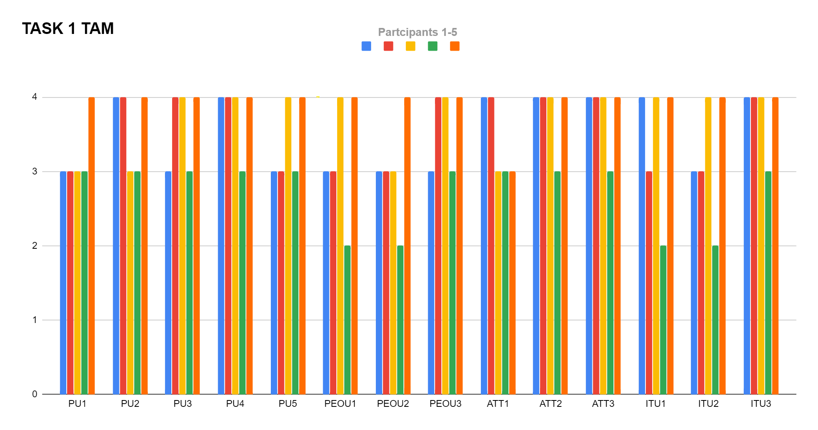

|  |  |
| --- | --- |
| **Label** | **Task** |
| PU1 | I can accomplish setting up a life goal more quickly using Sleep Fine. |
| PU2 | I can view achieved and current life goals more easily using Sleep Fine. |
| PU3 | Sleep Plan enhances my effectiveness utilizing a life goal management system |
| PU4 | Sleep Fine enhances my efficiency in utilizing seeing what goals I have achieved |
| PU5 | Sleep Fine enhances me to make better decisions in utilizing good sleep for achieving life goals |
| PEOU1 | It is easy to use Sleep Fine to accomplish my life goals |

Figure 2

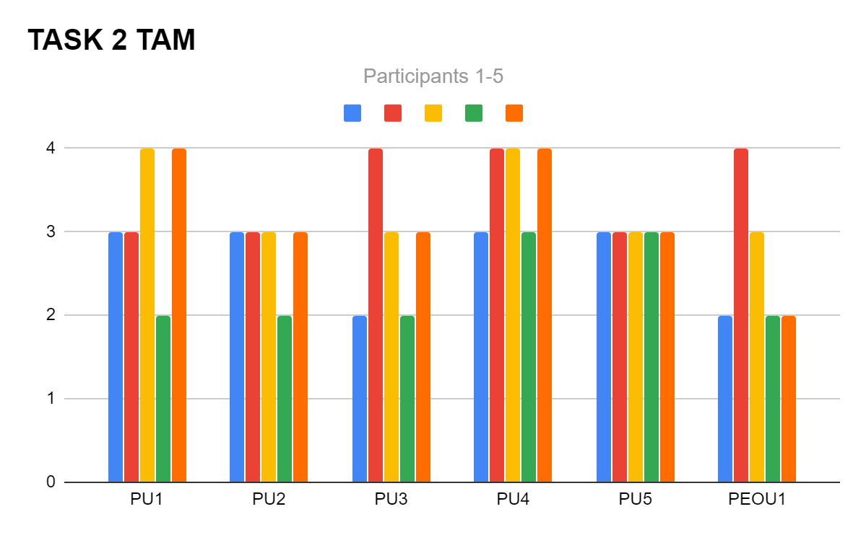

|  |  |
| --- | --- |
| **Label** | **Task** |
| PU1 | I can accomplish viewing my required vs actual sleep more quickly using Sleep Fine. |
| PU2 | I can view notification life goals more easily using Sleep Fine. |
| PU3 | Sleep Plan enhances my effectiveness utilizing a health risk advisory support system |
| PU4 | Sleep Fine enhances my efficiency in utilizing graphical analysis of my sleep |
| PU5 | Sleep Fine enhances me to make better decisions in sleeping with notification support of my goals |
| PEOU1 | It is easy to use Sleep Fine to accomplish my life goals and achievements with graphs and notifications |

Figure 3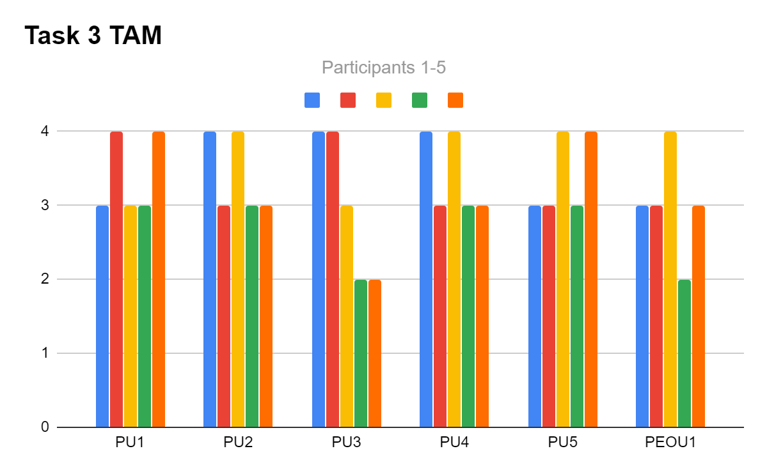

|  |  |
| --- | --- |
| **Label** | **Task** |
| PU1 | I can accomplish viewing community threads about sleep more quickly using Sleep Fine. |
| PU2 | I can view a medical sleep report more easily using Sleep Fine. |
| PU3 | Sleep Plan enhances my effectiveness utilizing an automated medical sleep report to send to my GP |
| PU4 | Moderating posts by country enhances my comfortability in utilizing a platform to share and view others ideas |
| PU5 | Sleep Fine enhances me to make better decisions in sleeping with other ideas |
| PEOU1 | It is easy to use Sleep Fine to accomplish an accurate report for my doctor to view my sleep |

Figure 4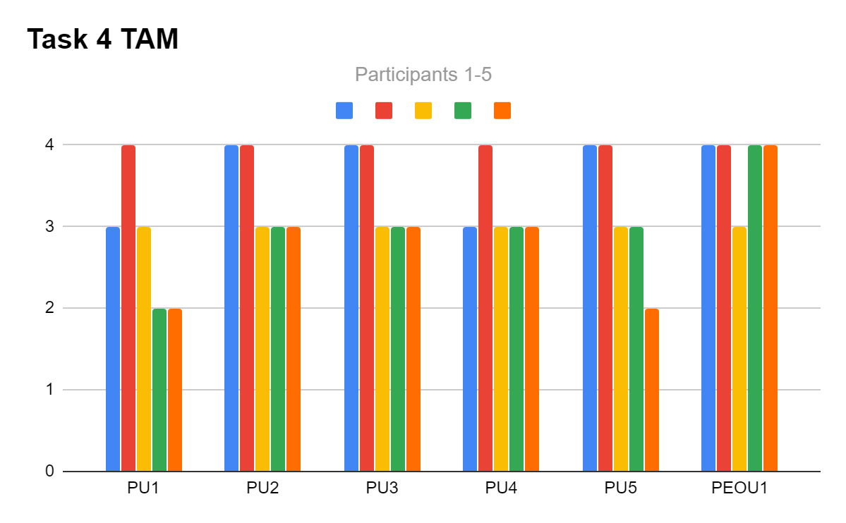

|  |  |
| --- | --- |
| **Label** | **Task** |
| PU1 | I can accomplish changing the app's appearance and features more quickly using Sleep Fine. |
| PU2 | I can change the app's appearance and features more easily using Sleep Fine. |
| PU3 | Sleep Plan enhances my effectiveness utilizing an application interface made for me |
| PU4 | Sleep Fine enhances my efficiency in utilizing a an application that settings meets my needs |
| PU5 | Sleep Fine enhances me to make better decisions in how my interface appears and functions |
| PEOU1 | It is easy to use Sleep Fine to accomplish changing the apps settings to work how I would prefer whilst keeping all the same features |

Figure 5

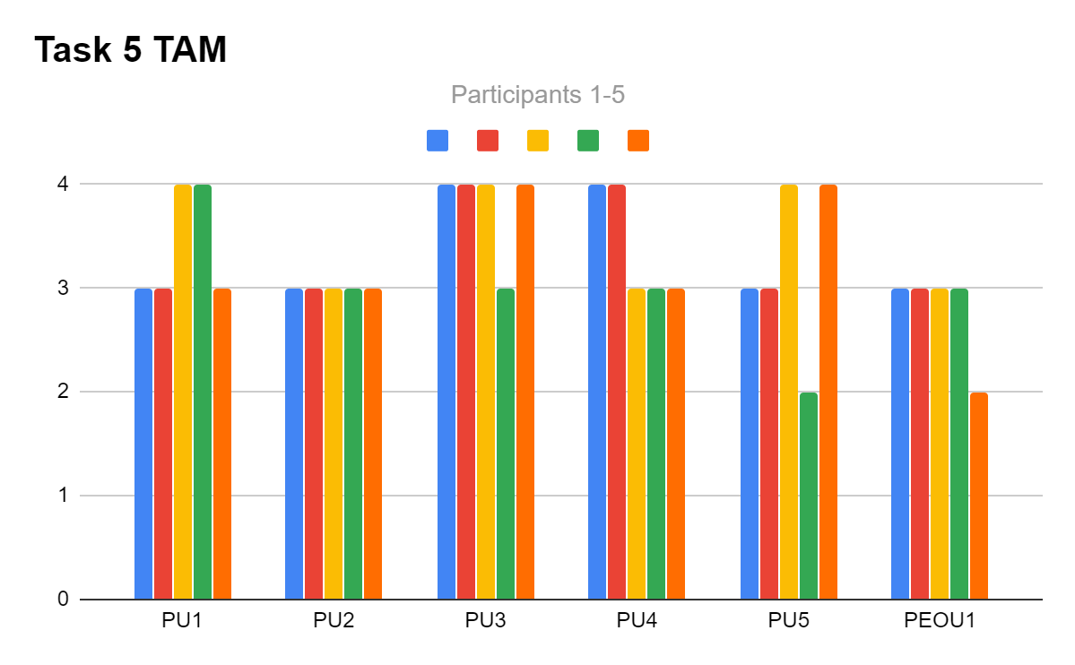

Notes and Graphical Analysis

After the Technical Acceptance Model (TAM) was conducted the five participants were questioned over their selected responses for each task. Responses of significance include participant 4, who stated “I chose that I disagree with using Sleep Fine in the future regularly because it feels too much to manage”. The other significant response was more supportive by strongly agreeing to recommend Sleep Fine to other users. Participant 2 said “I said I would recommend this to others because I know lots of people that struggle with sleep and this would really help them”. These two responses highlight both revisions to the conceptual model to retain users for the long term with multiple functions, as well as the justifies the included features as effective for sleep management.

The figures above outline participants' response of the 4 dimensions measured by the TAM evaluation method. The first task analyzed the participants of setting up a sleep program. The majority of participants agreed it was strongly useful, the ease of use was lower with participants agreeing and disagreeing, and all participants aside from participant 3 who disagreed with the Attitudes towards technology and intention to use criteria. From this, it is supported that setting up a sleep plan needs to be made more simplified and intuitive.

The next TAM task was the management of life goals and achievements. The perceived usefulness of this task ranged from mostly agree to strongly agree, with participant 3 the outlier disagreeing about the usefulness about the life goals. For the perceived ease of use 3 participants disagreed about the feature being easy to use. From this, it can be deduced that the goals and achievements feature is useful to the end user, however needs to be revised for simplicity, to enable end users to use this feature.

The third TAM task evaluated was the sleep performance and notification support features. The perceived usefulness was strongly agreed and agreed upon by participants, however participants 4 and 5 disgreeded about the health risk features usefulness. The perceived ease of use was agreed (3) and strongly agreed (1) by participants, from this the performance and notification features have an ease to use UI and are useful to the participants management of their sleep. A new issue identified was the inclusion of a health risk feature, since it was found as not useful by the participants this needs to be revised in the conceptual model to be more useful to end users.

The next TAM task was the online community and medical sleep report features. From the (Figure ??), the perceived usefulness of these features was mostly agreed and strongly agreed with. However as identified from the Design Walkthrough evaluation, the usefulness of threads feature was disgreeded by partpants 4 and 5. This needs to be changed to more simple recognition words like ‘Topic’ or ‘Posts’ in the conceptual model. For creating a sleep medical report, the perceived ease of use was strongly agreed (4) and agreed (1), suggesting this feature is well designed for user needs and requirements.

The final TAM evaluation was for the Settings features, which found the majority strongly agree and agree responses for the perceived usefulness. The perceived ease of use criteria was also agreed (4) as a majority. Participant 4 disagreed that a changing settings feature to meet their needs wouldn’t improve their experience of using the application. When further questioned, it appeared evident that participant 4’s lack of mobile application technical knowledge was a reason for this response, hence an out of scope issue was omitted from analysis. Participant 5’s disagreed about the setting ease of use, when questioned this coincided with earlier Design Walkthrough analysis of the meaning of default privacy settings. This already identified issue, would require a page for users to accept and understand the meaning of default privacy settings when using the application.

**Low Fidelity Prototype Checking Questions**

How

The final evaluation method technique was the Checking Questions method. This was done through the software application ‘Zoom’ in an interview format. Before this interview was conducted, the five participants were required to partake in both the Design Walkthrough and TAM evaluations. The participants were questioned about their understanding and assumptions of the applications following features:

1. How a sleep plan is created
2. Goals and achievements
3. Notification and Sleep performance
4. Community and Sleep Medical Report
5. Settings

Prior to conducting the Checking Questions interview, the assumptions for these five features were noted to allow comparison with participants assumptions. Before the interview in accordance with the Checking Questions Protocol (**APPENDIX**), the participants signed consent forms and were given instructions about how the interview will be conducted.

What Information and Why

The information provided from the Checking Questions evaluation includes both alignment and mis-alignment of any features in the application, from a diverse range of end users. The purpose of conducting this interview is to ensure the established assumptions match the assumptions of participants, this ensures that features of the application are being interacted with the intended purpose.

Variation

The only variation was to reduce the protocol interview time of 80 minutes to 20 minutes. This was due to the fact that the five participants were well versed in understanding the Sleep Fine low-fidelity prototype and how it worked. Hence, asking about various assumptions gained a quick response from participants due to their familiarity.

Results

The results of significant expected assumptions and participant assumptions for each task is outlined in the (Figure ??????)

|  |  |  |
| --- | --- | --- |
| **Task** | **Expected Assumption** | **Participant Assumptions** |
| Task 1 | Users need to synch wristband immediately  Profile is used to create a sleep plan  Re-Evaluate sleep plan generates a new easier sleep program | The application automatically syncs with wristband P[1]  Sleep plan is automatically 8 hours and profile is just how people appear to others P[2]  Re-Evaluate:  Creates a new sleep plan using personal body information P[5]  Gives an easier sleep program to follow P[3] |
| Task 2 | Goals and Achievements are life long/short term ambitions  Goals are set to motivate users to follow a sleep plan and once achieved transforms into an achievement | Goals is how the sleep plan is created and your goal sleep hours P[2]  Goals are motivation and after reach goal this appears in achievements P[3,4,5] |
| Task 3 | Notifications provide support to sleep better and achieve life goals  Sleep Rating the average of how much actual sleep deviates from required sleep over the total days of the program  Health risks is the current health risks users face from their current sleep | Notifications exist as support for users to achieve current goals P[1,2,3,4,5]  Sleep rating is how close users follow the sleep program P[1,2,3,4,5]  Health risks is the risks anyone faces from bad sleep P[1]  Health risks is the health risks the user faces from current sleep P[2,3,4,5] |
| Task 4 | A moderator is used to filter content for each countries needs including cultural or religious needs  Community is a platform to discuss and share ideas about sleep  The thread function allows users to post topics for discussion  The medical sleep report generates a sleep chart in multiple file formats of sleep for personal or medical use | Moderation is used to make users feel comfortable with regards to a specific country’s values P[5]  Don’t understand what moderation means P[1,2,3,4]  The community page is used to discuss with others about sleep P[1,2,3,4,5]  Threads are used to post topics P[5]  Not sure what a thread is P[1,2,3,4]  The medical sleep report generates a sleep chart in multiple file formats of sleep for personal or medical use [1,2,3,4,5] |
| Task 5 | Settings is used to change the appearance of the application  Privacy is the default settings that users agree when installing the application | Settings is used to change the appearance of the application P[1,2,3,4,5]  Didn’t agree to default privacy setting nor is the terms and conditions outlined  P[1,2,3,4,5] |

*Figure ????? Note P[x] refers to participant(s) x*

Notes and Analysis

From the Checking Questions it is evident that the expected assumptions have both alignment and mis-algnment with the end users assumptions about the application. From Task 1 results, changes that need to be made is that the synchronized wristband screen needs to pop up when first using the application. The sleep plan is generated based on the user's body and not a generic 8 hours for adults needs to be made more clear with a seperate user profile and set up sleep plan pages. The ‘Re-Evaluate’ button needs to be explained to users as a tool to assist users with a modified sleep program to support users struggling to meet current sleep program expectations. The Task 2 results found that the Goal and Achievement feature needs to be made clear as a life goal manager and not an input for sleep goals. Task 3 results uncovered that the health risks need to be reworded to portray the users current health risks. From Task 4 the moderation feature needs to be reworded to explain the inclusivity system requirement feature of ensuring users values are respected. Furthermore, the word ‘Thread’ needs to be changed to ‘Post’ to align with participants' recognition of how posting topics works. Finally, Task 5 analysis found that users weren’t aware of what the default privacy settings terms and conditions were, hence in the next iteration of the conceptual model an initial page to accept and read the default privacy setting will need to be developed.

**Revised Conceptual Design**

**Revised Contextual Enquiry Research:**

Health risks corresponding to poor sleep patterns include impaired attention, alertness, concentration, reasoning and problem solving. Severe long term impacts include health complications such as Heart attack/problems, diabetes and high blood pressure [1]. Adults require on average 7-9 hours of daily sleep, but 35% fail to achieve this [2].

Many existing forms of hardware exist to manage individuals' sleep. Current technologies and methods for sleep management include Smart Watch, Biometric Mattress, Mobile Phone Noise Listener Application, which all use sensors which can record heart rate, body temperature and sleeping periods [3]. The current technologies for sleep management have deficiencies including the following. The Phone recording noises for sleep can be inaccurate due to interference from external noise. The mattress requires the user to be still and in a single position when sleeping which is difficult for a user to do. The smart watch with the display screen is expensive and not affordable to the average student. The Mattress system works by a user sleeping on top of it, the sensor recording movements when the heart pumps blood and the user breathing. This is then wirelessly sent to a mobile app. Current smart watch technology uses two methods to track a user's sleep pattern. The device uses a wrist motion tracker combined with heart rate and body temperature sensors to formulate a sleep pattern. The mobile application system works by using the phones internal microphone to measure respiration, snoring, sleep periods and possible health conditions such sleep apnea. [4]

Many forms of existing software applications exist to manage individuals' sleep. This includes the application ‘Sleep Cycle’. This application utilizes the phones built in microphone to record noises, and processes this data to determine which sleep stage cycle the user is in. This data is then processed and displayed as a graph, the app also uses AI machine learning to determine an ‘optimal’ wake up and sleep time for the user [5]. Another existing solution includes the IOS application ‘AutoSleep Tracker’, which is linked with the ‘Apple Watch’ hardware. This application connects the biometric watch to track sleep and other parameters of the human body to predict how a user will cope with the rest of their day. The user interface is similar to the IOS 'Activity Tracker application, with how sleep information is displayed in coloured graphs and numbers [6].

**Revised Problem Statement:**

Design and develop an application system that records users' sleep cycle and provides an accommodating sleep plan, whilst informing users of their sleep health, encouraging users to achieve life goals and providing a community platform for users to interact with others around the world.

**Additional Key Interface Metaphors**

From the evaluation methods conducted it was clear that users didn’t understand the moderation feature of posts by region; Don’t understand what moderation means P[1,2,3,4]. From the TAM 4 evaluation all participants agreed with “Moderating posts by country enhances my comfortability in utilizing a platform to share and view others ideas”, suggesting this feature was necessary to include in the application. Hence a new iconography symbol was selected as represented in (Figure 1). This icon has both a shield and lock, which represents the symbolism of being protected. When paired with a textual explanation, users can learn the meaning of posts that are moderated. This learnability icon gives users a new experience of posts that are moderated by country, with time of interacting this symbol will be easy to recognise rather than recall.

Figure 1: Moderated Symbol [9]

**Revised Initial System Requirements:**

**Community Feature:**

Secondary Level Features:

Simple interface for users to view and discuss and posts opinions and concepts on topics.

Rationale:

Users that have pondering questions or helpful tips or ideas related to sleep can communicate those ideas within topical posts to help the applications community develop healthy sleep cycles.

Notes:

The posts have an AI moderator which considers the current users country and culture to ensure they are not exposed to any discussion that is offensive to them. Users have the option to turn this feature on/off and is first explained then represented by a safe symbol. Users earn user rating points if other users rate their advice as helpful.

**Analyse Sleep Data Feature:**

Secondary Level Features:

Include graphical display of sleep performance, Sleep rating performance and List of current health risks that the user faces. As well as produce a sleep medical report to view personally or send to a doctor.

Rationale:

The application is used by an individual to maintain a healthy sleep cycle. The display of users' sleeping performance enables them to understand the implications of their sleep cycle and whether it is impacting positively on their health and life goals. The health risks feature enables users to understand what risks their body is at based data collected from their sleep. Users that wish to create an accurate digital copy of their sleep within a given time period.

Notes:

Users that have a poor sleep cycle deduced by the system are given the option of a sleep cycle plan with lower expectations and smaller incremental steps towards a healthy sleep cycle with the button to re-evaluate my plan. The medical sleep report generated contains a detailed report of a user's sleep cycle in a given period. The simple rating and graph is easy to understand for all users without medical jargon as from the interviews conducted;"I used an app like once but i can't be bothered to check it and the medical jargon is confusing" [7]

**Synchronise Wristband**

Secondary Level Features:

Key GUI action to synchronise wristband to app.

Rationale:

To ensure a lower cost and maintained accuracy of sleep analysis data is gathered from the wristband. Users are required to synchronise their wristband to the app only once and other times when changing batteries or a new band.

Notes:

The popup window for using this feature has the synchronise screen popup to users after accepting the privacy settings when first using the app, and is available anytime after using the navigation bar. The process is required to be simple and mostly automated. Users press a synch button on the band and the synch icon on the app after accepting privacy settings, this interaction automatically creates a wireless bluetooth connection between the devices.

**Personalised Sleep Program**

Secondary Level Features:

Interface to input details that is used to create a sleep plan

Rationale:

The system is designed to cater users based on their personal information such as age, height, location, ethnicity, religion and weight and compare it to stored information to determine a specific sleep plan based on stored information.

Notes:

The sleep plan is clearly outlined in the application to the users that the plan is customized to their personal traits. Users should have the option for a one week trial of measuring sleep cycles, the system will then factor this data in with the personal data to determine an appropriate sleep management plan. This ensures that a sleep program is not unattainable. Coinciding with interview [7], users of any sleep ability can have personalised guidance on how to sleep.

**Capture Sleep Data**

Secondary Level Features:

Store sleep data on mobile and cloud databases, and clear data from wristband.

Rationale:

The sleep data is captured from a biometric wristband when a person sleeps, this data is transmitted via bluetooth to the mobile device. For the data to be stored it is transmitted to the cloud database and used in other features.

Notes:

To ensure memory is maintained on both the wristband and mobile device, after the data is transmitted both have the sleep data of that cycle deleted locally. Users privacy is to be protected with the database cloud having protection systems implemented.

**Manage Goals and Achievements**

Secondary Level Features:

Set life goals the user would like to achieve currently in life with a text interface, have the app notify encouragement of how a good sleep cycle is helping those goals. A system of visual GUI achievements of goals to show users their progress.

Rationale:

The use setting life goals meets the contextual inquiry need of a motive for users to keep using the application. The user can feel satisfaction and progress with the app with the achievement GUI to understand the importance of a healthy sleep cycle in their life.

Notes:

The setting of life goals is moderated to ensure the goal is not inappropriate. Users are notified during the day of their goal and how their current sleep cycle is affecting this goal. Users can view and edit their achieved goals in the achievements, as part of the motivation issue found to sleep; "Mate i got no motivation to do that aye"[8]

**App Settings**

Secondary Level Features:

GUI to alter appearance and some functions of the application, and popup window for accepting default privacy settings.

Rationale:

Enabling user customisation coincides with conceptual design of usability and mobile guidelines. With the ability to select language, dark mode, privacy settings. Furthermore the ability to send feedback via a text entry ensures users can express their opinions on the application, as well as access user documentation for any assistance when using the application.

Notes:

When users first open the application they will be presented with a screen for accepting the default privacy conditions. Users also have a text entry and a submit button, when submitting feedback to the developers.

**Reducing Cognitive Load**

To improve the low-fidelity prototype usability the following principles and laws were integrated into the revised conceptual model:

* Gestalts Principles [10]
* Hicks Law [10]

**Gestalt Principles**

**Proximity:**

For the placement of the graph and sleep rating objects, these should be placed next to each other, to show users how the sleep rating depends on how the users sleep performance graph looks like. The health risks should be placed underneath both of these objects, since users didn't understand these were their health risks, placing it under the two objects instead of above, should enable users to understand that the health risks derived from both the graph and sleep rating for them.

**Similarity:**

For the entering of user data, there should be two separate colored windows, once that is for entering information to create a sleep plan the other for a personal information to use in the online community. The sleep plan window should be colored light blue, which is associated with sleep and the personal information window light orange which is representative of being awake, hence the users presence in the online community.

**Common Fate**

An issue identified was the usability of the community section and sleep medical report generator. With the moderation feature this should be done first, then with an arrow pointing to the organised table of ‘Topical Posts’ not ‘Threads’ and moving arrow at the bottom showing that there are more pages of Topics. For the medical sleep report feature, there should be a tick next to the action required for time period, file type and then the option to share or save the file only shown when the predecessor is completed.

**Hicks Law**

It was identified that the goals priority system was overcomplicated, hence this input field was removed, and users were given a scrolling option to scroll and drag goals up and down the list. Even though a ‘Home’ button existed once tapped users didn’t know that they were on the home page , to reduce the number of taps the home page will have the additional text “HOME” written to reduce the time spent determining if users were on the correct home page.

**Personas**

**Data Collection:**

The type of users that are the target end user for the ‘Sleep Fine’ application ranges broadly. Since the purpose of the application is to support adults sleep better, this coincides with the health issue that 1 in 3 adults aged between 18 and 60 fail to achieve the minimum required sleep for optimum health and wellbeing [11]. Hence the age range of the potential users would be adults of any gender between 18 and 60. From the initial contextual inquiry interviews it was evident that existing underlying issues existed with current systems being “too expensive” [12] and people that “can't be bothered” [13] as well as not having high intellectuality “medical jargon is confusing” [13]. Given this for users financial background it is good to understand both middle and upper class, health or non-health conscious and users with differing intellectual capacities. Since the application is sleep dependent it would be feasible to understand users that have a good sleep pattern and poor sleep pattern, to understand both aspects of the application to help users sleep better and maintain a good sleep pattern. An upper class user could be a BOEING 777-300ER captain and a middle class user a graduate Software Engineer earning salaries of $264,000 and $59,000 [14,15]. An IQ test is used to measure intellectual capacity, with high considered above 132, average around 116 and below average and less than 100 a low IQ [16]. Testing users within this range enables understanding of the cognitive load of the implied design interface.

**Hypothesis:**

From the data research collected the types of users that will potentially use the ‘Sleep Fine’ application will be adults aged between 18 and 60. People between lower middle and upper class. Individuals that will use this app would be working or a student occupation. The simple mostly automated design of the application warrants individuals with IQ capacities between 80 and 200 to use the app, with their UX being a differing factor. The backgrounds of the user's current sleep pattern and management will include users that have sleep patterns and behaviour that is poor, average and exceptional.

**Established Number:**

There will be three different types of persona users, each with differing characteristics and exercising both typical normality and extremity users.

User 1:

* “Typical”
* Middle Aged
* Has an average sleep schedule
* Doesn’t Manage sleep
* Upper class
* Average IQ

User 2:

* Upper Extremity
* Young age
* Has an exceptional sleep schedule and management skills
* Lower middle class
* High IQ

User 3:

* Lower Extremity
* Young Age
* Has poor sleep schedule
* Poor sleep management skills
* Middle class
* Low IQ

**User 1 [17]**

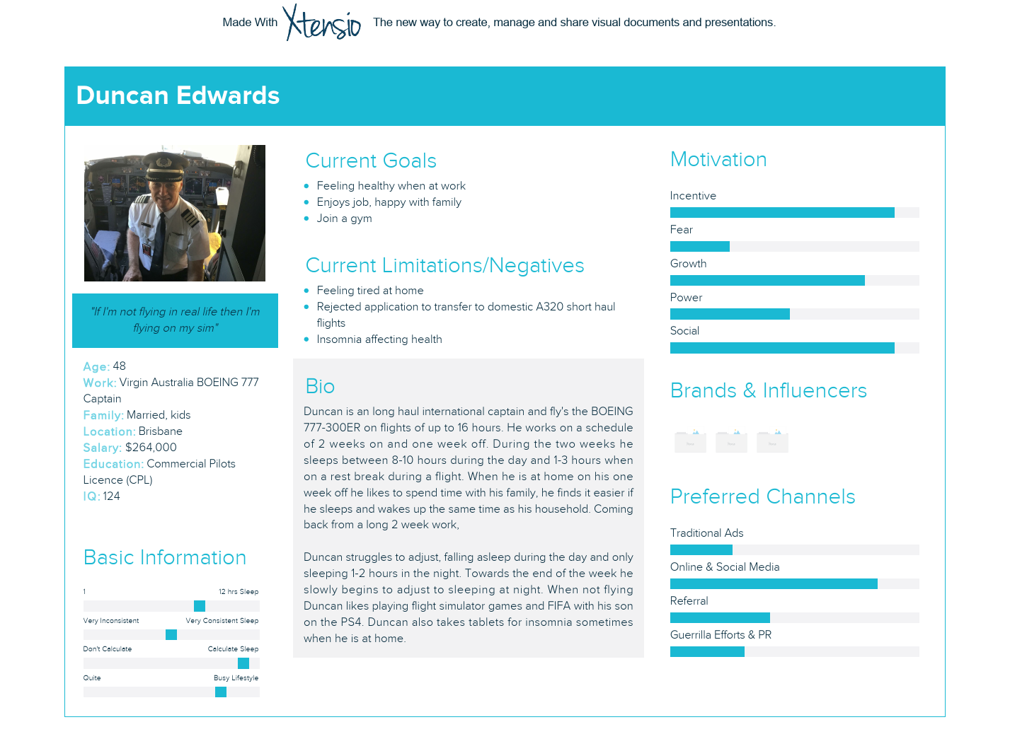

**User 2 [18]**

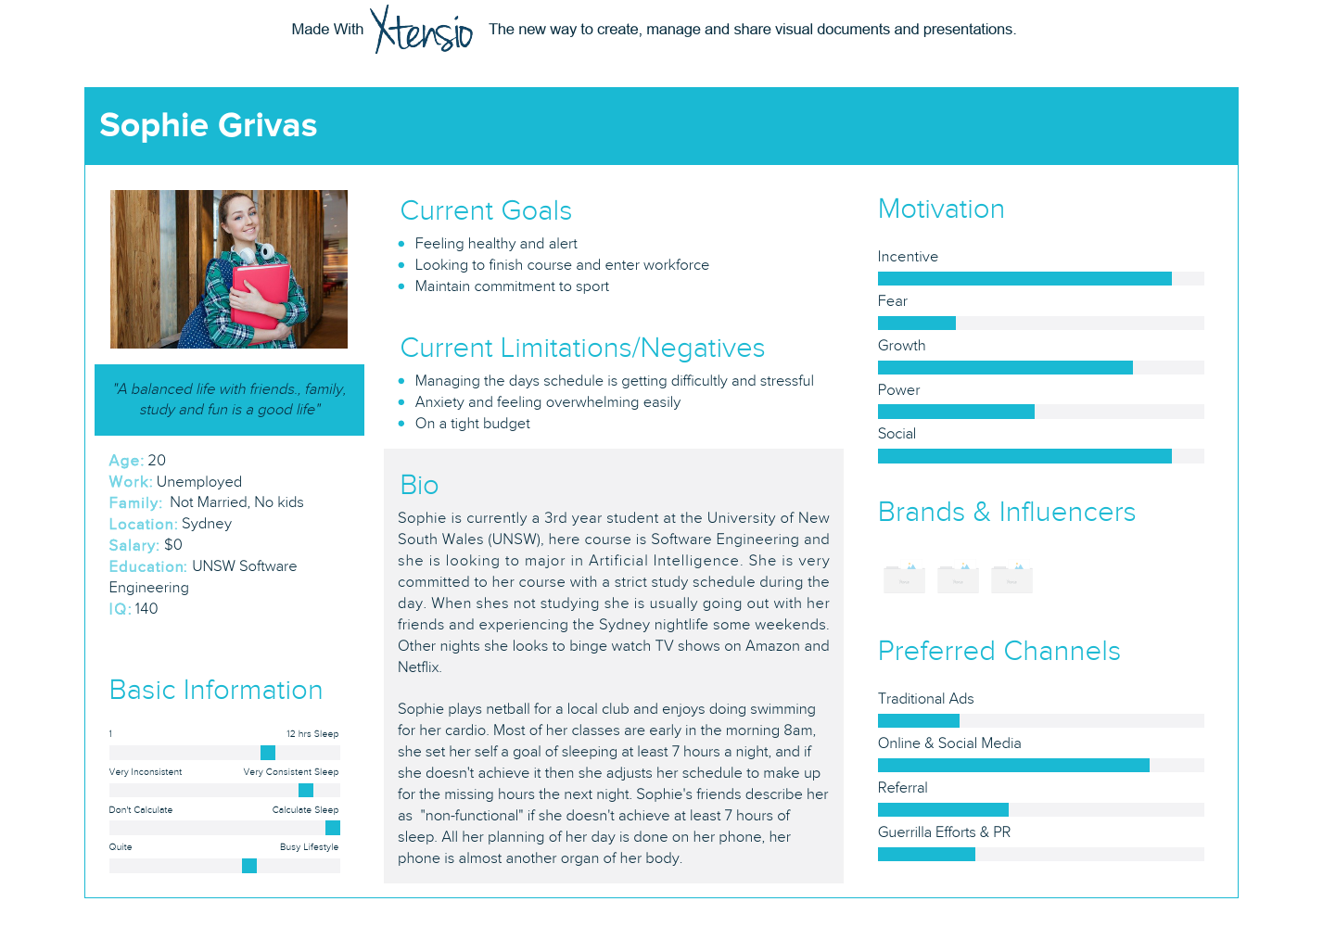

**User 3 [19,20]**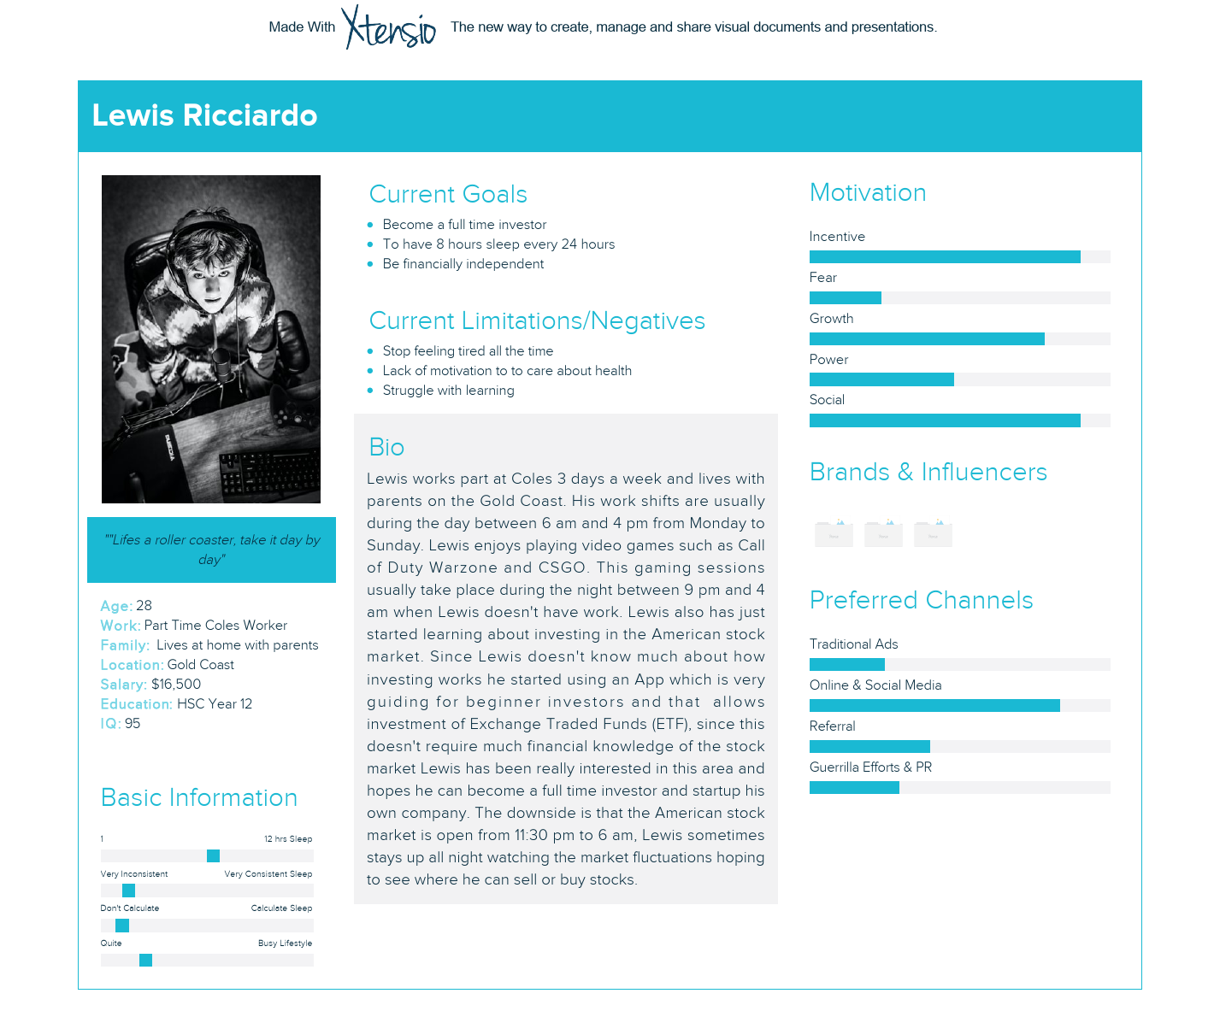

**Interaction Scenarios**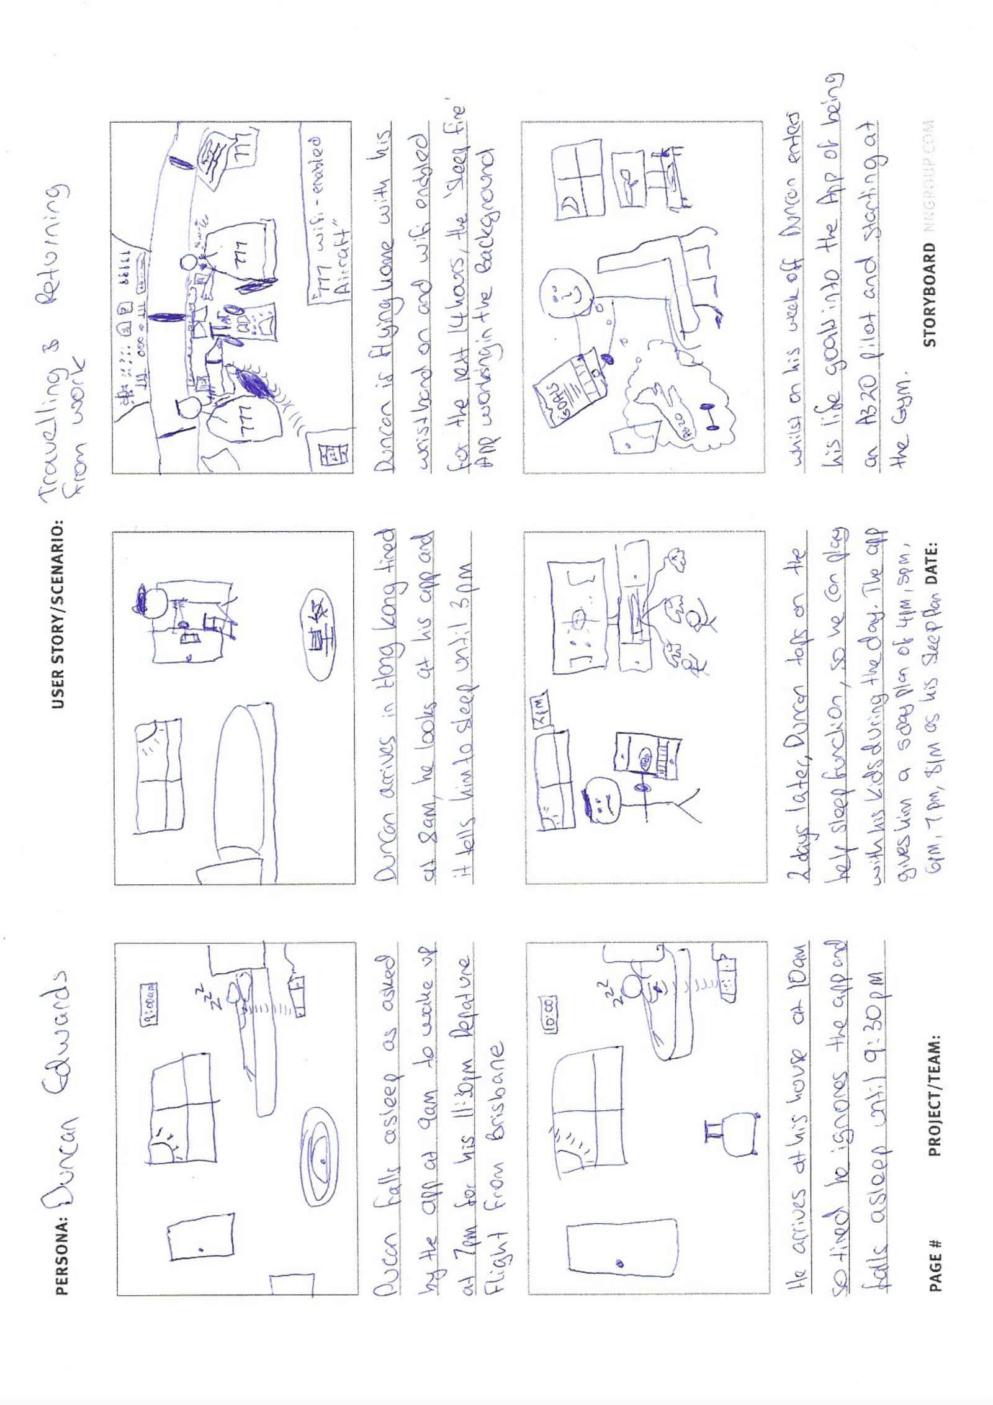

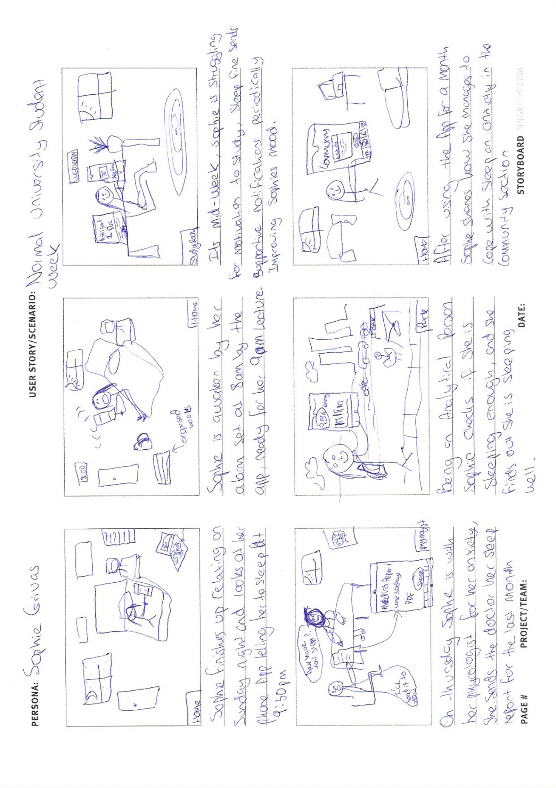

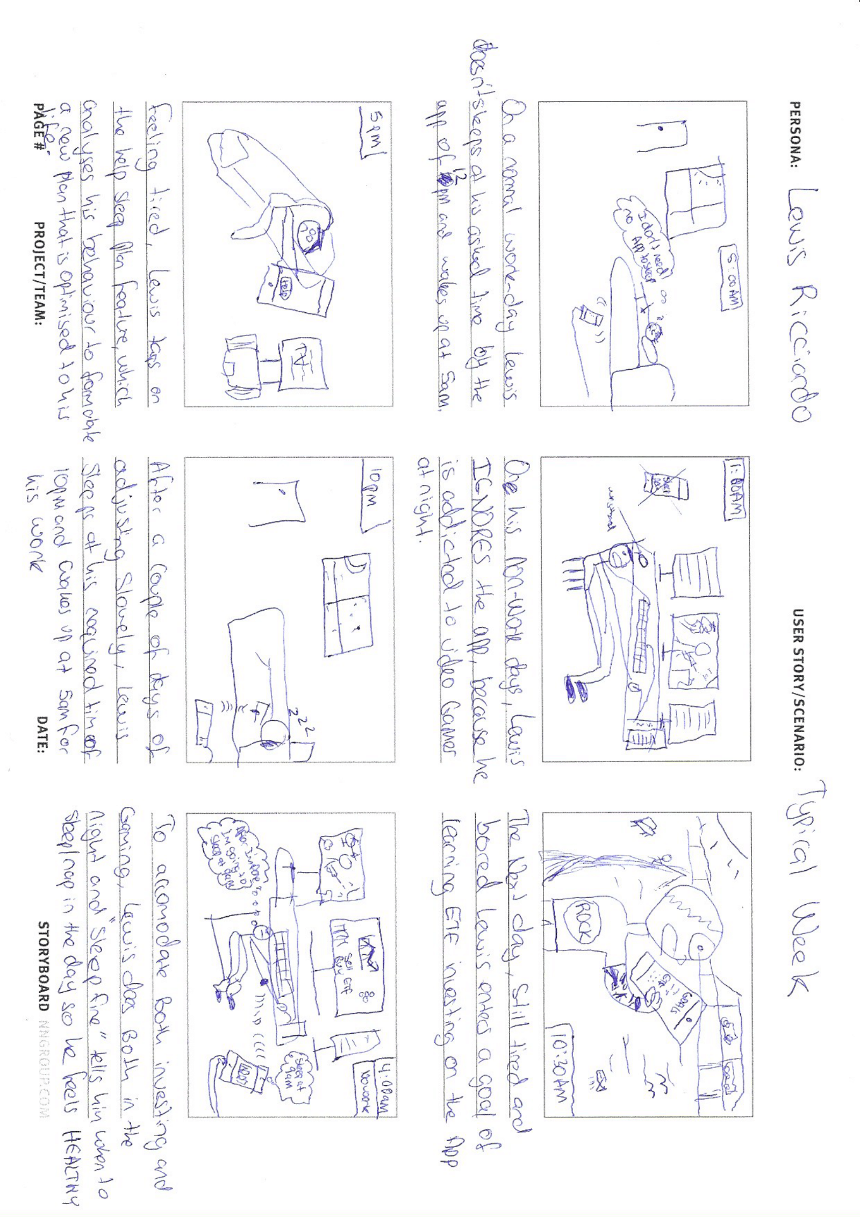

**UX Goals**

|  |  |  |  |
| --- | --- | --- | --- |
| **Source** | **UX Goal** | **Measures** | **Requirements** |
| **Design Walkthrough Issue:**  Determining Which screen was the home page P[1,2,3,4]  Participants were not aware of default privacy settings were and didn’t consent to this setting P[1,2,4,5]  **Checking Questions Incorrect Assumptions:**  The application automatically synchronises with wristband P[1]  Didn’t agree to default privacy setting nor is the terms and conditions outlined P[1,2,3,4,5] | I want to start using the application to manage my sleep and life goals. | Number of Taps on interactive GUI to:   1. Understand usability of icons 2. Understand complexity of task   Number of Time taken to reach home screen to:   1. Understand difficulty and complexity from a time perspective and whether to reduce complexity   Survey Questions:   1. What were your thoughts on having privacy and terms and conditions as an option to agree to instead of being default? 2. Was the process of synchronising the wristband hard to follow? (negative scoring)   Interview : Open ended any thought/opinions about this task? | * Written privacy terms of conditions of use is written for users to accept as the first screen when using the app for the first time * The setup of synchronising the wristband is done after accepting privacy conditions and then setting up a sleep plan is available * Home page needs to be defined as homepage so user knows where to navigate when lost * The set up of a sleep plan is done when first using the app before any home screen * Home page says the word “Home” on it and is accessible from any part of the app using the navigation bar. It contains basic overview messages like sleep rating and notification feed. |
| **Design Walkthrough Issue:**  Finding where to input personal data P[1,2]  Understanding what icon correlates to creating a sleep plan P[1,2,4]  Distinguishing Between Re-Evaluating and Creating a new Sleep Plan P[2]  Struggled to distinguish between expected and actual sleep P[1,2,3]  **Checking Questions Incorrect Assumptions:**  Sleep plan is automatically 8 hours and profile is just how people appear to others P[2] | I want to create a sleep plan that is customised to me and view this sleep plan. | Number of Taps on interactive GUI to:   1. Understand usability of icons 2. Understand complexity of task   Number of Time taken to set up and view sleep plan to:   1. Understand difficulty and complexity from a time perspective and whether to reduce complexity   Survey Questions:   1. I understood the difference between setting up information for my sleep program and online profile? 2. I couldn’t differentiate what was my required and actual sleep in the graph? (negative scoring) 3. How did you perform in sleep for the last 2 weeks with a health rating at the end of it? 4. Are the health risks general health risks of bad sleep or your current health risks?   Interview : Open ended any thought/opinions about this task? | * Entering sleep generating related information needs to be seperated from personal online details and simple to understand * Fields for entering personal and sleep data consist of free text and drop down elements. * The health rating and health risks need to be positioned under the graph to understand the users required sleep performance per night * Graph, Health rating and health risks show how a user is performing * Scroll feature and date selector inside the graph is available to view performance for a time period. * Pages can be navigated to via the navigation bar at the bottom of the application. * Sleep plan automatically generates plan in graph using users details and AI machine learning with a central database * Hover icon to explain each section for generating a sleep plan. |
| **Design Walkthrough Issue:**  Proposed an odersing feature instead of priority to drag current goals up and down P[2]  Proposed an ordering feature instead of priority to drag current goals up and down P[2]  Misunderstood life goals as sleep goals P[2]  Didn’t tap add after entering a goal P[2]  **Checking Questions Incorrect Assumptions:**  Goals is how the sleep plan is created and your goal sleep hours P[2] | I want to create and manage life goals, as well as be supported to achieve these goals and follow my sleep plan. | Number of Taps on interactive GUI to:   1. Understand usability of icons 2. Understand complexity of task   Number of Time taken to set up, edit and view goals in goals and achievements page to plan to:   1. Understand difficulty and complexity from a time perspective and whether to reduce complexity   Survey Questions:   1. I know what the purpose of goals are for? 2. Ordering my goals by dragging was difficult to do? (negative scoring) 3. How many goals do you have currently only looking at the Home page? 4. What happens when you achieve a goal 5. The notifications of support were encouraging to follow my sleep program better?   Interview : Open ended any thought/opinions about this task? | * Goals and Achievements icons are clickable and able to be navigated to via the navigation bar * The badges feature for the goals corresponds the the number of current goals for the user * Clear explanation with a hover icon that the goals feature is life goals and in no way correlated to setting up a sleep plan made clear when first using this feature. * Input fields only take in the goal name not a priority number. * Interface to drag goals up and down the viewable box. * Edit button next to each goal to edit the text of the goal. * Trophy icons in the achievements page are mounted on the hunting wall, with a tap sensitive interface to show achieved goals. * Share button, to share picture of achieved goals page. |
| **Design Walkthrough:**  Process of generating a sleep report was quick and easy P[1,2,3,4,5]  Having a detailed medical report easily accessible and accurate was a good feature P[1,2,5]  **Checking Questions Assumptions:**  The medical sleep report generates a sleep chart in multiple file formats of sleep for personal or medical use [1,2,3,4,5] | I want to create a medical sleep report so that I can send it to my doctor for analysis of sleep, because my measuring of the time I sleep is inaccurate. | Number of Taps on interactive GUI to:   1. Understand usability of icons 2. Understand complexity of task   Number of Time taken to generate and send doctor a medical report for a given time period to:   1. Understand difficulty and complexity from a time perspective and whether to reduce complexity   Survey Questions:   1. How would you generate a medical sleep report for the last 2 weeks? 2. Generating a medical sleep is worse than telling my doctor how much I felt I slept? (negative scoring) 3. Why would the next steps only appear after you did the previous steps? 4. Was finding the medical sleep report page easy or hard?   Interview : Open ended any thought/opinions about this task? | * GUI to select time frame, file format and ability to export the generated report to local device or share with doctor * Medical report icon has a navigational expansion from the ‘more’ icon on the home page allowing access to extra icons.      * Help hover button that explains the purpose of the medical report generator feature. * Hidden and Unhidden steps in the process appear in correct order when the user completes each step in generating a medical report. |
| **Design Walkthrough Issue:**  Participants didn’t understand the moderation feature for community page P[1,2,3,4,5]  Didn’t understand the concept of a thread P[1,2,3,4]  Didn’t find how to post own thread P[1,2,4]  **Checking Questions Incorrect Assumptions:**  Moderation is used to make users feel comfortable with regards to a specific country’s values P[5]  Don’t understand what moderation means P[1,2,3,4]  The community page is used to discuss with others about sleep P[1,2,3,4,5]  Threads are used to post topics P[5]  Not sure what a thread is P[1,2,3,4] | I want to express my opinions and read others on multiple sleep related topics using the Community page, as well as only view content in my country of choice. | Number of Taps on interactive GUI to:   1. Understand usability of icons 2. Understand complexity of task   Number of Time taken to filter by a country, post on a topic and view a topic to:   1. Understand difficulty and complexity from a time perspective and whether to reduce complexity   Survey Questions:   1. How would you only choose posts from your country? 2. Is it bad to filter by country since you might miss out on posts by people in other countries? (negative scoring) 3. Why would the next steps be to post on an existing topic? 4. Do you prefer the word ‘post’ or ‘thread’? 5. How can you sort the display by most recent comment? 6. Why would you search for a specific post by typing when you can just scroll?   Interview : Open ended any thought/opinions about this task? | * Community icon is embedded in the ‘more’ icon and is interactable to bring up the community page. * The select region drop down feature filters posts for a selected country or **ALL** countries if chosen and is moderated by AI machine learning for appropriateness. * The moderation feature is explained by a hover tap button. * The GUI table contains topics, posts, date of post and most recent post with intractable sort buttons to sort content by user selected field. * A post GUI exists to post a users opinion on a new topic as well as on existing topics. * Scroll bar exists on the sidebar to navigate down the page as well as a search bar to filter posts by keywords. |
| **Checking Questions Incorrect Assumptions:**  Profile is used to create a sleep plan P[1,3,4,5]  Sleep plan is automatically 8 hours and profile is just how people appear to others P[2] | I want to change my profile appearance that I come across as online. | Number of Taps on interactive GUI to:   1. Understand usability of icons 2. Understand complexity of task   Number of Time taken to create a community profile to:   1. Understand difficulty and complexity from a time perspective and whether to reduce complexity   Survey Questions:   1. How would you create a profile of which people see you as in the online community? 2. I got confused between setting up information for a sleep plan and community profile? (negative scoring) 3. Would you prefer two seperate pages one for information for creating a sleep plan the other for an online profile?   Interview : Open ended any thought/opinions about this task? | * Profile page is accessible as an icon from anywhere in the application by clicking on the single person icon. * GUI to enter personal details and select a profile picture. * Display of score next to profile which is calculated from post upvoted in the community section. * Hover tap button that explains the difference between sleep generating personal information and online community personal information. * GUI to save or update personal community profile. |
| **Design Walkthrough Issue:**  Distinguishing Between Re-Evaluating and Creating a new Sleep Plan P[2]  **Checking Questions Incorrect Assumptions:**  Re-Evaluate:  Creates a new sleep plan using personal body information P[5] | I want to generate a new easier sleep plan because the current one is a struggle to meet expectations. | Number of Taps on interactive GUI to:   1. Understand usability of icons 2. Understand complexity of task   Number of Time taken to generate a new easier sleep program to:   1. Understand difficulty and complexity from a time perspective and whether to reduce complexity   Survey Questions:   1. How would you generate a new sleep plan to meet your ability currently? 2. The button ‘Help New Plan’ is confusing? (negative scoring)   Interview : Open ended any thought/opinions about this task? | * The GUI for accessing the page where users enter information for generating a sleep plan is complete and all fields are filled. * Button for “Help New Plan” which generates a slow “stepped” incremental sleep program for the user. This would update the GUI of the graph in the ‘My Sleep’ page and modify notification messages. |
| **Design Walkthrough Issue:**  Participants were not aware of default privacy settings were and didn’t consent to this setting P[1,2,4,5]  Feedback entry field was difficult to use and send feedback P[1,2,4]  **Checking Questions Incorrect Assumptions:**  Didn’t agree to default privacy setting nor is the terms and conditions outlined  P[1,2,3,4,5] | I want to modify the settings of the application to meet my custom needs. | Number of Taps on interactive GUI to:   1. Understand usability of icons 2. Understand complexity of task   Number of Time taken customise app to french, dark mode, no notifications, send feedback and view user documentation in chrome/safari to:   1. Understand difficulty and complexity from a time perspective and whether to reduce complexity   Survey Questions:   1. How would you find the settings page from the Home page? 2. It is bad that privacy is default from what I accepted at the start (negative scoring). 3. Is the switch tab consistent with the interface design of my mobile operating system? 4. Would it be better for user documentation to open within the app or external browsing app already installed on users device?   Interview : Open ended any thought/opinions about this task? | * The GUI for the dark mode and push notification switch tab meets both IOS and Android needs. * GUI to change language changes the entire textual appearance of the app, dark mode changes app to mostly black and inverted text, notifications can be disabled within the app. * Drop down GUI to change from default privacy to custom privacy settings and text entry field to send user feedback, which is sent as an email format to the developer.      * Tappable button which opens the user documentation in the users desired browser application with permission first from the user. |

**Medium Fidelity Prototype**

**ADD PICTURES OF BOTH IOS AND ANDROID STUFF HERE**

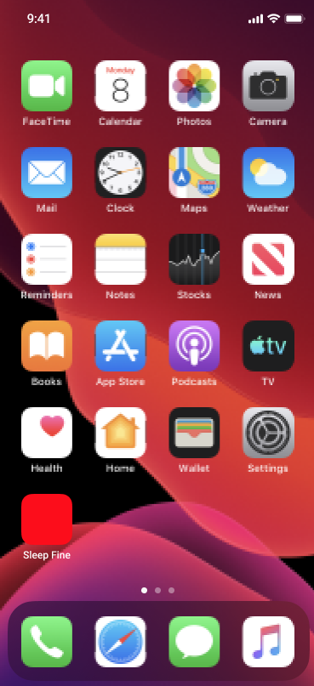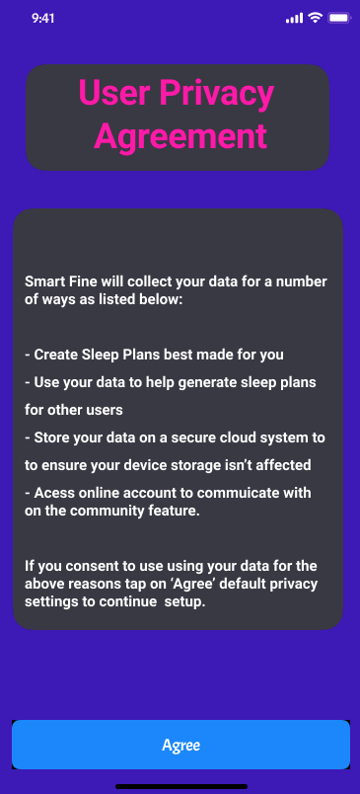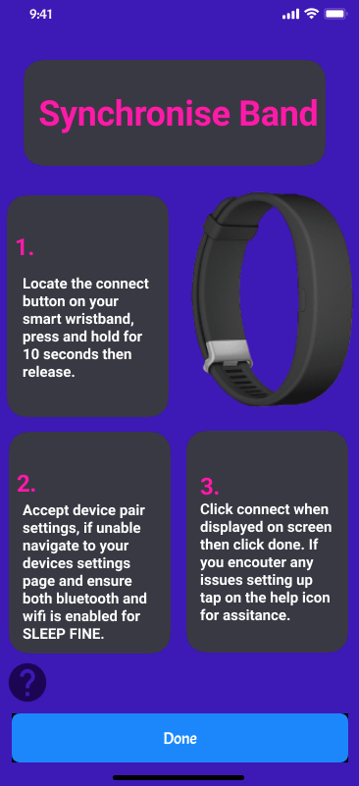

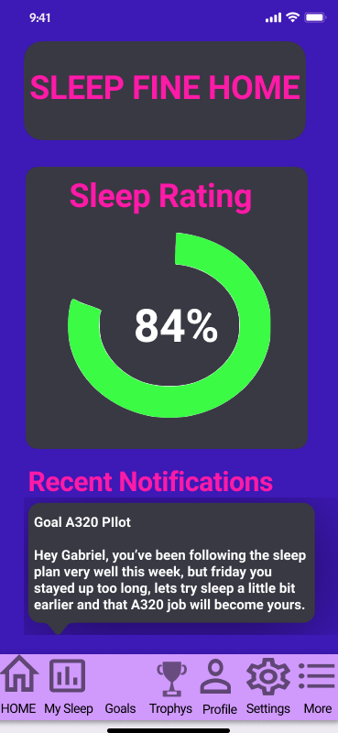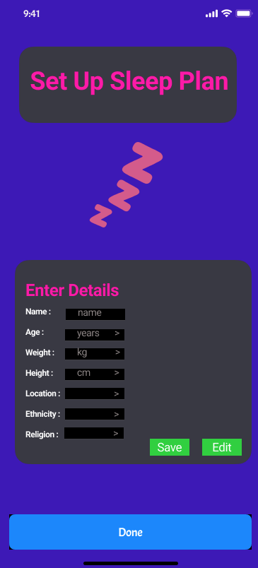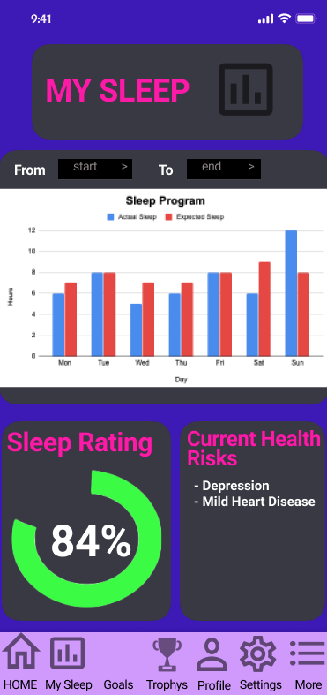

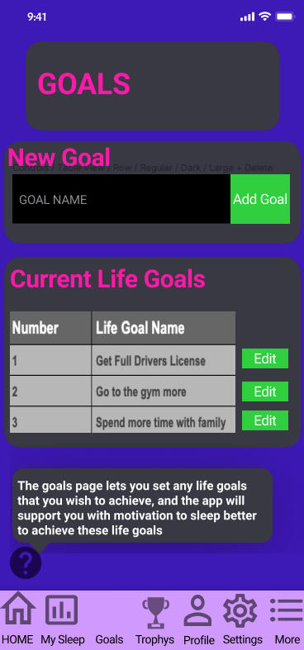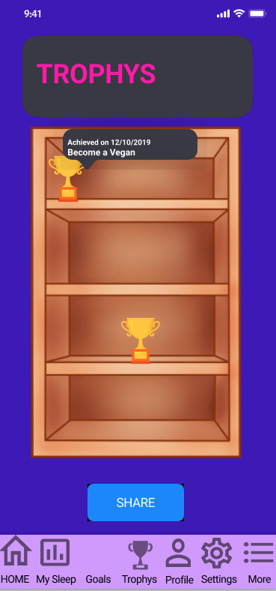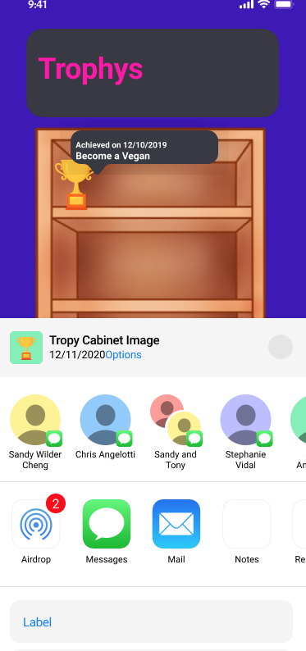

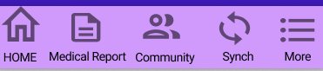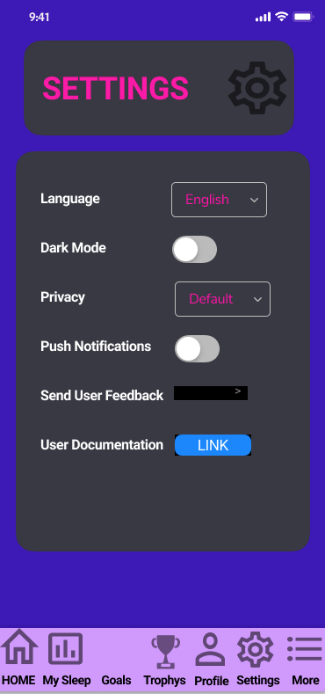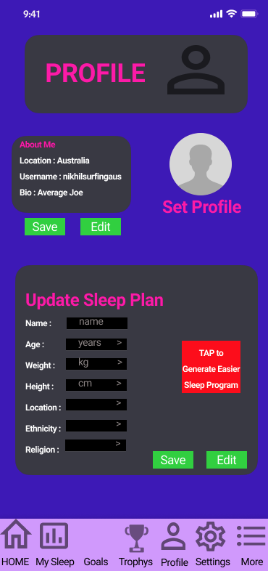

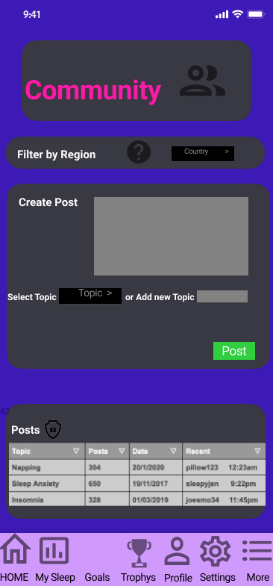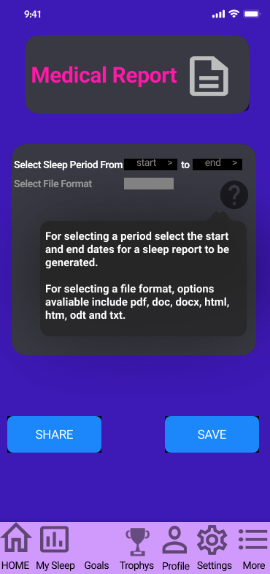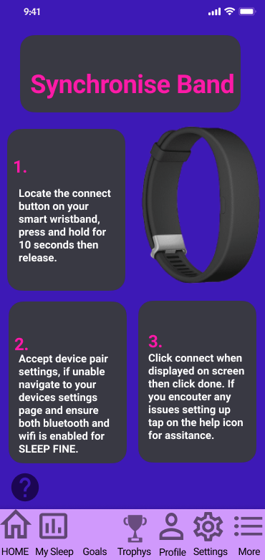

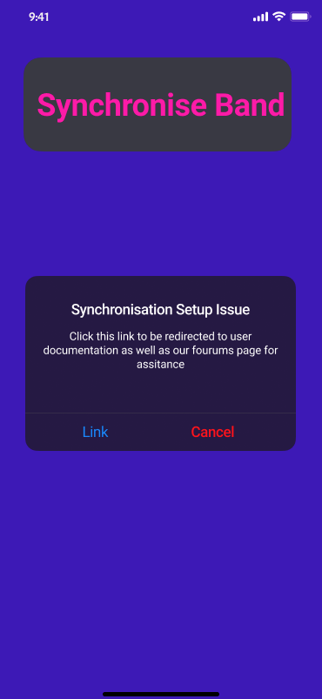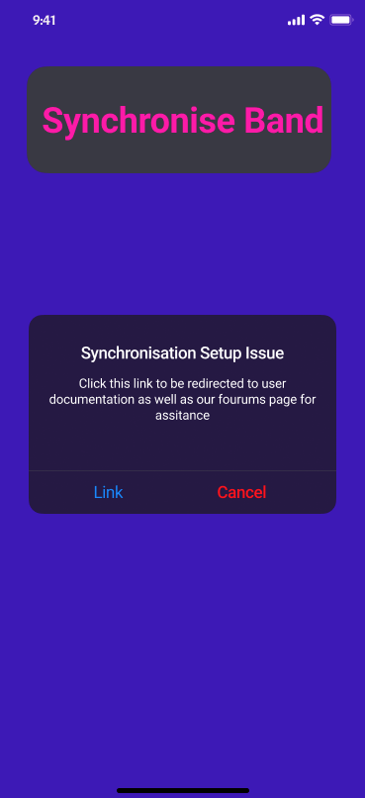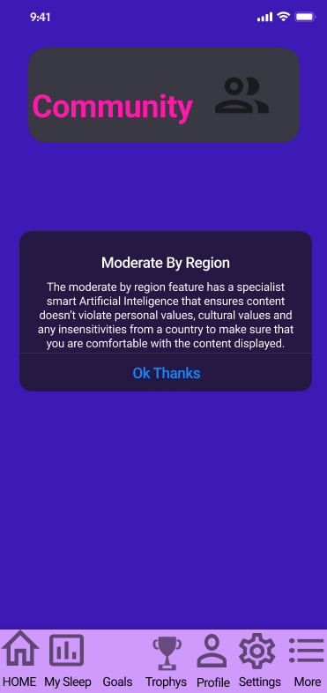

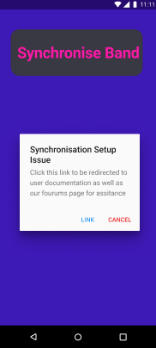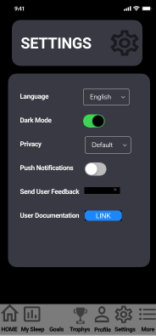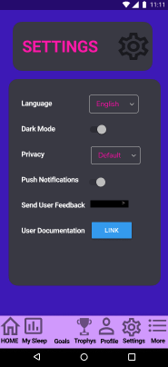

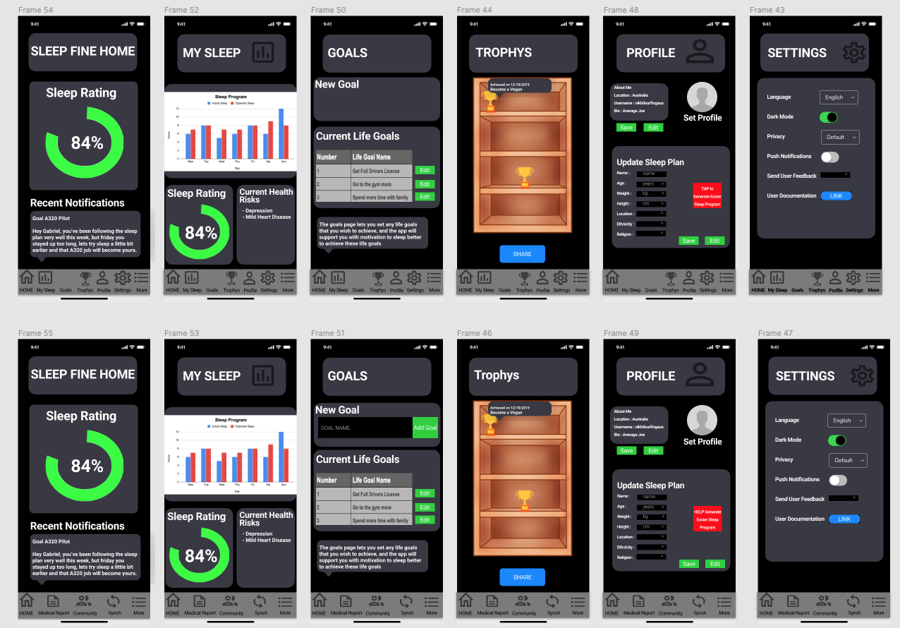

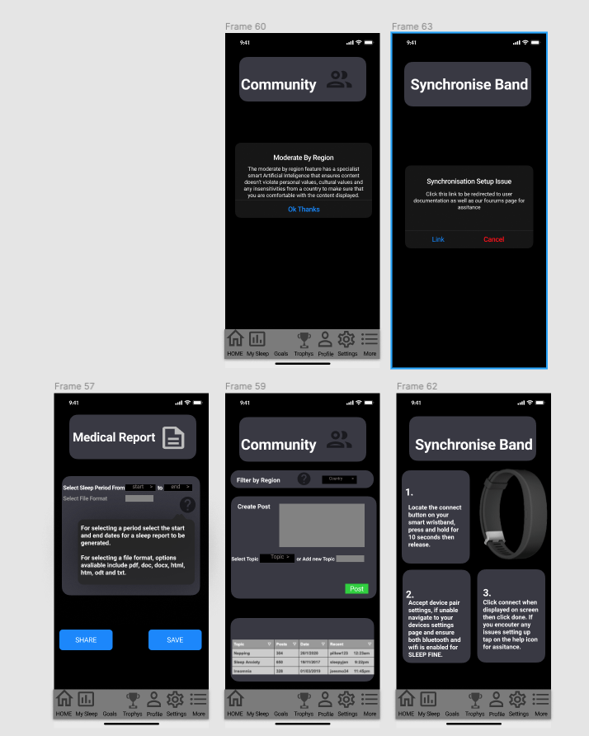

**Medium Fidelity Prototype Evaluation**

**System Usability Scale**

**How**

The System Usability Scale evaluation method was conducted through the application ‘ZOOM’ with participants in an interview format through the zoom medium at first. The participants were then explained the process and purpose of the SUS evaluation method in accordance with the SUS Protocol (**APPENDIX**). The participants were then given 20 minutes to interact with the Medium-Fidelity Prototype, via the mobile prototyping online software tool ‘Figma’. After interacting with the new prototype, the five participants were sent 3 sets of 10 questioned Google Forms SUS surveys to fill out. At the end of each survey the participants were questioned why they selected an answer on the 1-5 scale, but were not given the chance to change their answers after completing the survey.

**What Information and Why**

The purpose of the SUS evaluation method was to understand the usability of the medium-fidelity prototype in terms of the UX and UI. Using a 3 sets of 10 questions, a SUS score for usability could be referenced and analysed for each participant, to understand deficiencies and revisions that need to be made in terms of the UX and UI usability of the Medium-Fidelity Prototype. To also understand the usability of the system as a whole, averaging SUS data ignores outliers in responses, hence by creating a Box-Plot visualization, this would help understand the distribution of response, of whether possible usability issues fall into the majority of minority of participants usability issues.

**Results Figures**

The questions used for the SUS evaluation are illustrated in (Figure ???????)

|  |  |
| --- | --- |
| **Question Number** | **SUS Question** |
| 1 | I felt comfortable being prompted to agree with Sleep Fines privacy and user agreement before use. |
| 2 | I found the synchronization process of the wristband unnecessarily complex. |
| 3 | The entry fields for creating a sleep plan were easy to use and the save, edit and done commands were simple to follow. |
| 4 | The sleep rating wheel and percentage colors were difficult to read. |
| 5 | The bottom navigation bar icons were simple to understand and transitions between pages was fast.The bottom navigation bar icons were simple to understand and transitions between pages was fast. |
| 6 | The color layout was inconsistent throughout the application. |
| 7 | The Sleep Program was simple and easy to use and selecting a time period of sleep was quick and easy. |
| 8 | It was difficult to understand whether the health risks were for me or general health risks of poor sleep. |
| 9 | The creating, editing and viewing life goals elements were well integrated and simple to use. |
| 10 | The tap help feature explaining what the goals feature did was confusing and difficult to understand. |
| 11 | The trophy cabinet with trophy's elements were well integrated in displaying completed life goals. |
| 12 | The share trophy cabinet pop up was difficult to use and was inconsistent with the rest of the application, |
| 13 | The customization of my online profile had sufficient information that I would want to display online about myself. |
| 14 | The design of having both the personal details and sleep plan creation details in the single page was hard to use. |
| 15 | The settings icons was well integrated with my IOS/Android operating system. |
| 16 | I didn't feel enough features of settings to satisfy my customization of the app.I didn't feel enough features of settings to satisfy my customization of the app. |
| 17 | The dark mode colors was consistent with my perception of dark mode in reducing eye strain. |
| 18 | Returning back to the Home page was a slow process from any page in the application |
| 19 | more navigation icon was simple to use in revealing more icons |
| 20 | Generating a medical sleep report was a cumbersome process and the steps were confusing. |
| 21 | The 'save' and 'share' icons in generating a medical report were consistent with my Android/IOS devices user interface design. |
| 22 | The file types available in the drop down box were insufficient. |
| 23 | I was easily able to post my opinions on a new or existing topic in the Community page. |
| 24 | The filter by region feature was difficult to understand and the interactive help icon didn't clarify my understanding of this feature. |
| 25 | The option for me to re-synchronize my wristband would not require me asking for technical support to re-synchronize |
| 26 | The shapes of the buttons throughout the application were not appealing and felt inconsistent throughout the app.The shapes of the buttons throughout the application were not appealing and felt inconsistent throughout the app. |
| 27 | The help icon tappable feature transition was smooth and pop up was consistent with my IOS/Android devices user interface |
| 28 | I would not use the application Sleep Fine frequently |
| 29 | I will recommend this app to others |
| 30 | The icon on my iphone was not good in appearance |

The SUS scores are summarized in the (Figure????)

|  |  |  |  |  |  |
| --- | --- | --- | --- | --- | --- |
| Questions | Participant 1 | Participant 2 | Participant 3 | Participant 4 | Participant 5 |
| 1-10 | 85 | 82.5 | 82.5 | 87.5 | 97.5 |
| 11-20 | 85 | 82.5 | 82.5 | 87.5 | 100 |
| 21-30 | 67.5 | 80 | 80 | 85 | 92.5 |
| Average Grade | 79 | 82 | 82 | 87 | 97 |

The final results we're the Box-Plot distributions for each of the three sets of SUS questions as evident in (Figures x-z ??????)

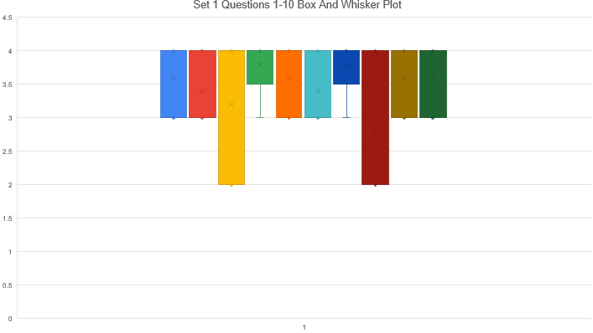

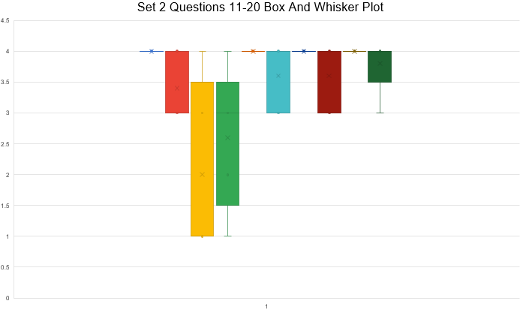

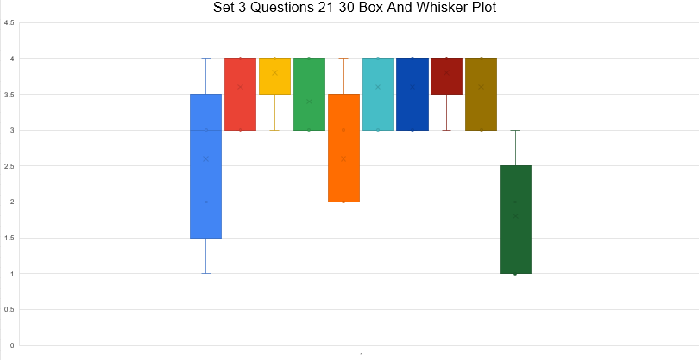

**Analysis**

To understand the participants' SUS scores the SUS score graph in Figure (???????) will be used to interpolate participants' grades.

Lecture Week 8 [x]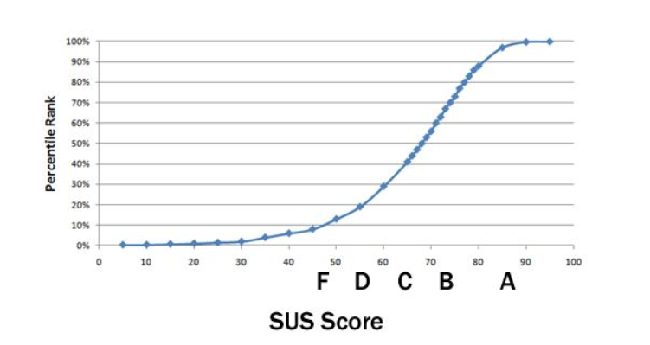

The participants grades can be explained as the following for the UX and UI usability questions:

* Participant 1 (Low A, Low A, C) - Average Low A border B
* Participant 2 (Low A, Low A, Low A) - Average Low A
* Participant 3 (Low A, Low A, Low A) - Average Low A
* Participant 4 (Mid A, Mid A, Mid A) - Average Mid A
* Participant 5 (High A, High A, Mid A) - Average High A

Interpreting these results shows that the UX and UI usability for questions 1-20 were within the low grade A range (82.5-100). With this the questions covered the initial setup of the applications sleep plan, navigation, colour consistency, sleep health management, life goals, trophy cabinet, online profile, updating sleep plan, dark mode and android design. This demonstrates the success of these features, placing less priority on revising these UX and UI features in the revised model. For the questions 21-30, these were within a B range of (67.5-92.5), much less than the previous questions. The features covered include the sleep report, community page, wristband synchronisations, UI shapes, help icons UI/UX and the application home screen icon appearance. From this lower score, to bring this average up to an A score revisions need to be made in the usability of these features to improve the UI and UX.

The next figures include the Box-Plot distributions, which allowed visualization of the distribution of response. From (Figure 1) questions 1,2,5,6,9 and 10 participants were in agreement of SUS questions. Outliers that can identify questions 4 and 7. These questions pertain to the single disagreement of the sleep rating wheel and sleep program plan. Since the other participants were in majority agreement, these features should be looked into to revise usability, but a less priority placed on revising these.

In (Figure 2) questions 13,14 and 20 deviated from the upper quartiles. These questions were about the online profile, sleep plan personal details and generating a sleep plan. Question 13 had more than 50% of participants either neutral or disagreement with the ease of creating an online profile. Question 14 had both a strong agreement and disagreement with the usabiility creating a sleep plan. By negating these two answers, the median neutral response suggests revisions need to be made with the sleep plan details feature. Question 20 had one neutral response to the sleep plan generation, suggesting a low amount of revisions need to be made for its usability.

Finally in (Figure ???? ) questions 21, 23, 25 and 30 had some deviation in responses. The questions referred to the medical report saving/sharing, community page posting, synchronising and the home screen icon. For questions 21 and 25 both had outlier strong agreement and disagreements and a median neutral response. This suggests that the saving/sharing and synchronisation features usability needs improvement. The community page posting had one response neutral, however the upper 75% quartile lied in the strongly agreed category, suggesting little focus on improvement needed for this features usability. The last question 30, has the lower 50% quartile in disagreement with the home screen icon, this implies that the icon needs to be developed to be more appealing.

**Time Task**

**How**

The Time Task evaluation method was conducted via ‘ZOOM’ and screen share of the ‘Figma’ prototype view. Participants were read out the evaluations details in accordance with the Time Task Protocol (**APPENDIX**) to understand users performance speed of completing a task with respect to a predetermined benchmark time:

* Setting Up A Sleep Plan
* Goals and Trophies
* Online Profile
* Update Sleep Plan
* Access More Icons
* Medical Sleep Report
* Community Section
* Re-Synchronise Wristband
* Settings

**What Information and Why**

The purpose of conducting the Time on Task was to uncover any usability issues relevant with the ‘Sleep Fine’ applications UI and UX. This evaluation method was also used to see whether the predicted time taken to complete a task, matched the actual time to complete a task. By doing two runs of this method, the learnability of icons and the UX smoothness can also be analysed, to understand whether users improve after interacting with the interface multiple times. The information produced is the time taken to complete a task and the error count made by participants during the task process. By analysing this data, decisions in revising the conceptual model for the High-Fidelity prototype are reinforced.

**Results Figures**

From conducting a test evaluating the Sleep Fine applications feature, the benchmarking time set for each feature was based on the time taken as a developer to use a feature with a 5 second added. This additional 5 seconds was added to mitigate any bias with being the developer the navigation and understanding of Sleep Fines UX and UI would be higher than a typical user.

**Run 1:**

|  |  |  |  |  |  |  |
| --- | --- | --- | --- | --- | --- | --- |
| Task | Participant 1 | Participant 2 | Participant 3 | Participant 4 | Participant 5 | Benchmark Time |
| Create An Initial Sleep Plan When first using the application, with empty fields. | Time: 48.57  Error Count: 3 | Time: 71.18  Error Count: 3 | Time: 45.43  Error Count: 2 | Time: 30.4  Error Count: 1 | Time: 28.5  Error Count: 0 | 21.80 |
| Navigate to the created sleep plan and state current health risks. | Time: 18.42  Error Count: 1 | Time: 18.82  Error Count: 0 | Time: 10.2  Error Count: 0 | Time: 14.67  Error Count: 1 | Time: 9.01  Error Count: 0 | 5.90 |
| Navigate to the Goals page, create a goal of “be more fit”, and edit an existing goal. | Time: 65.01  Error Count: 2 | Time: 52.97  Error Count: 2 | Time: 30.5  Error Count: 1 | Time: 29.80  Error Count: 0 | Time: 23.56  Error Count: 1 | 14.70 |
| Find the trophies page and share an achieved goal with an existing phone contact. | Time: 56.07  Error Count: 2 | Time: 35.66  Error Count: 2 | Time: 30.2  Error Count: 1 | Time: 28.67  Error Count: 1 | Time: 21.78  Error Count: 1 | 10.90 |
| Edit your online profile with the word “null” for each field. | Time: 32.22  Error Count: 1 | Time: 61.57  Error Count: 4 | Time: 45.1  Error Count: 2 | Time: 56.6  Error Count: 3 | Time: 30.23  Error Count: 2 | 15.60 |
| Create a new sleep plan by adding 1kg to your existing weight. Then make the sleep plan change for an easier stepped mode. | Time: 16.96  Error Count: 1 | Time: 46.16  Error Count: 3 | Time: 14.7  Error Count: 0 | Time: 47.89  Error Count: 2 | Time: 13.69  Error Count: 1 | 9.90 |
| Generate a PDF medical sleep report for the last month and save it to your devices local files. | Time: 29.72  Error Count: 1 | Time: 74.84  Error Count: 5 | Time: 20.56  Error Count: 0 | Time: 23.56  Error Count: 0 | Time: 21.98  Error Count: 1 | 8.90 |
| Post the text “I need 8 hours sleep usually” under the Sleep Anxiety Topic in community. | Time: 20.85  Error Count: 1 | Time: 27.04  Error Count: 1 | Time: 15.89  Error Count: 1 | Time: 30.45  Error Count: 2 | Time: 18.42  Error Count: 0 | 7.90 |
| Change the app language to Spanish, then push notifications, then turn dark mode on, navigate to the home page then disable dark mode. | Time: 124.74  Error Count: 7 | Time: 49.99  Error Count: 2 | Time: 57.97  Error Count: 2 | Time: 60.78  Error Count: 3 | Time: 45.67  Error Count: 2 | 25.70 |

**Run 2:**

|  |  |  |  |  |  |  |
| --- | --- | --- | --- | --- | --- | --- |
| Task | Participant 1 | Participant 2 | Participant 3 | Participant 4 | Participant 5 | Benchmark Time |
| Create An Initial Sleep Plan When first using the application, with empty fields. | Time: 29.75  Error Count:1 | Time: 35.60  Error Count: 1 | Time: 30.4  Error Count: 1 | Time: 22.78  Error Count: 0 | Time: 22.6  Error Count: 0 | 21.80 |
| Navigate to the created sleep plan and state current health risks. | Time: 6.54  Error Count: 0 | Time: 11.05  Error Count: 0 | Time: 8.90  Error Count: 0 | Time: 6.90  Error Count: 0 | Time: 9.67  Error Count: 0 | 5.90 |
| Navigate to the Goals page, create a goal of “be more fit”, and edit an existing goal. | Time: 19.19  Error Count: 1 | Time: 30.17  Error Count: 1 | Time: 17.78  Error Count: 1 | Time: 22.34  Error Count: 1 | Time: 21.98  Error Count: 0 | 14.70 |
| Find the trophies page and share an achieved goal with an existing phone contact. | Time: 11.55  Error Count: 0 | Time: 13.89  Error Count: 1 | Time: 17.21  Error Count: 0 | Time: 15.78  Error Count: 0 | Time: 15.78  Error Count: 0 | 10.90 |
| Edit your online profile with the word “null” for each field. | Time: 15.56  Error Count: 3 | Time: 20.42  Error Count: 2 | Time: 23.67  Error Count: 1 | Time: 34.87  Error Count: 1 | Time: 23.90  Error Count: 1 | 15.60 |
| Create a new sleep plan by adding 1kg to your existing weight. Then make the sleep plan change for an easier stepped mode. | Time: 29.04  Error Count: 2 | Time: 15.65  Error Count: 1 | Time: 12.45  Error Count: 1 | Time: 32.71  Error Count: 1 | Time: 11.67  Error Count: 1 | 9.90 |
| Generate a PDF medical sleep report for the last month and save it to your devices local files. | Time: 9.06  Error Count: 0 | Time: 24.12  Error Count: 1 | Time: 11.90  Error Count: 0 | Time: 19.76  Error Count: 0 | Time: 12.90  Error Count: 0 | 8.90 |
| Post the text “I need 8 hours sleep usually” under the Sleep Anxiety Topic in community. | Time: 9.16  Error Count: 0 | Time: 10.68  Error Count: 0 | Time: 12.45  Error Count: 0 | Time: 15.89  Error Count: 1 | Time: 9.89  Error Count: 0 | 7.90 |
| Change the app language to Spanish, then push notifications, then turn dark mode on, navigate to the home page then disable dark mode. | Time: 75.4  Error Count: 3 | Time: 46.05  Error Count: 1 | Time: 45.89  Error Count: 1 | Time: 43.89  Error Count: 1 | Time: 30.87  Error Count: 0 | 25.70 |

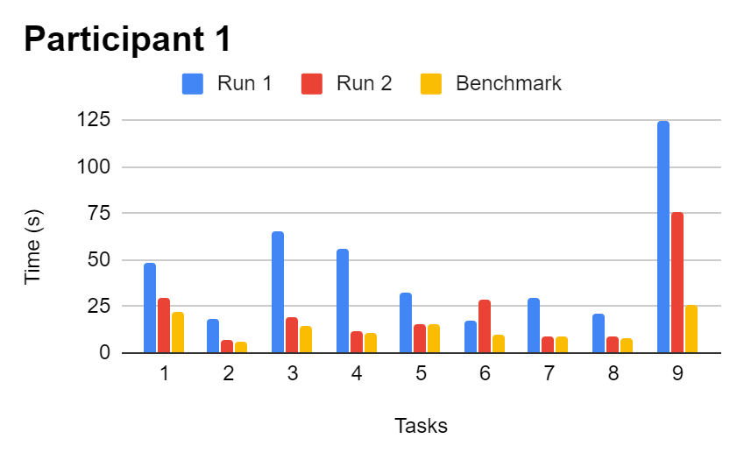

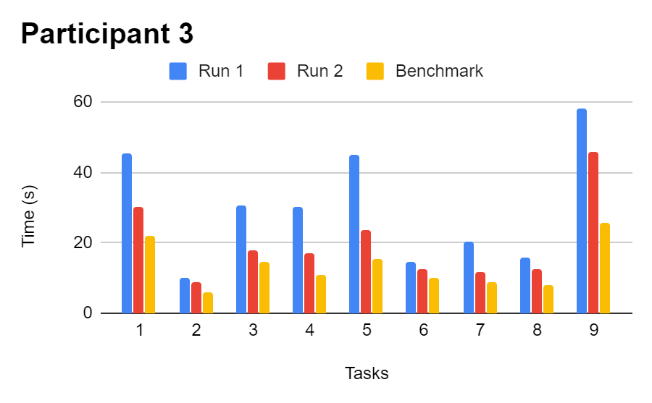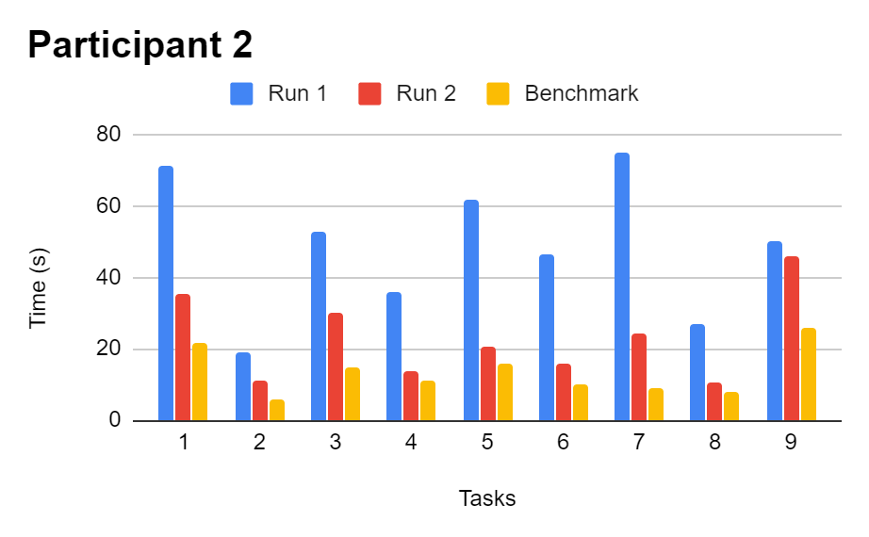

**Error Count:**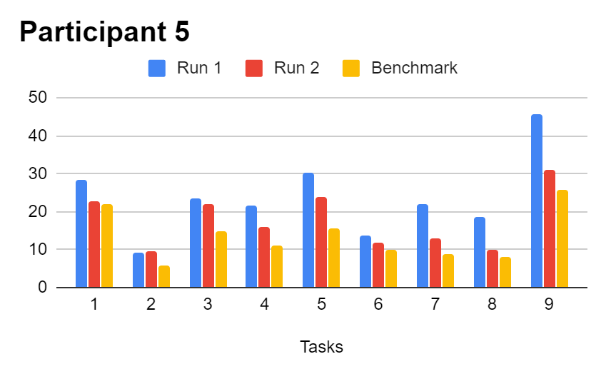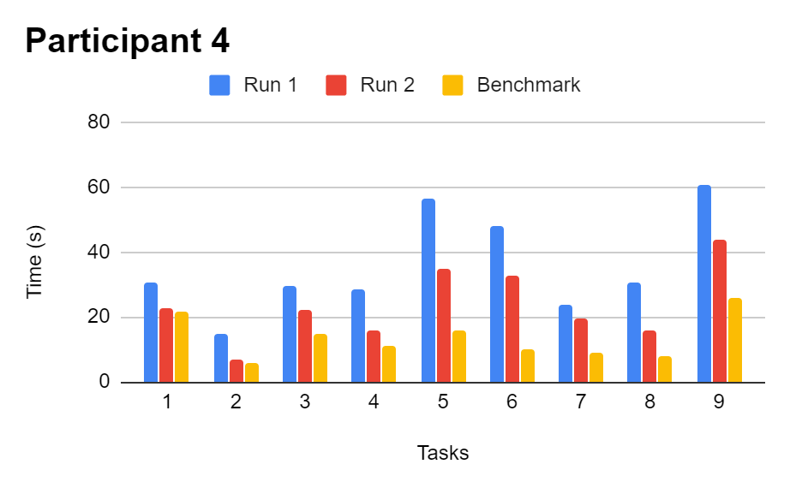

|  |  |  |
| --- | --- | --- |
| **Participant** | **Run 1 Error Count** | **Run 2 Error Count** |
| 1 | 19 | 10 |
| 2 | 22 | 8 |
| 3 | 9 | 5 |
| 4 | 13 | 5 |
| 5 | 8 | 2 |

**Analysis**

Calculations made from an excel of taking each run time and subtracting from the benchmark to produce an average deviation time from spreadsheet was used to support the interpretation of the visualization of (figures 1-5). In Figure 1 participants run 1 was an average deviation from the benchmark times of 63% for the tasks, which is evident by the higher blue line. In run 2 the average deviation was 23%, this 40% improvement supports the learnability and integration of recognition icons. It can be noted that in task 6 of creating a new sleep plan the participant was slower suggesting an issue with this features usability. Participant 2’s (Figure 2) run 1 was an average benchmark deviation of 71%, which improved to 39% in run 2. Another 32% improvement in speed, with task 9 of using the settings not improving suggesting a usability issue with the settings interface. Participant 3 (Figure 3) had a 52% deviation in run 1 and in run 2 bettered with an average benchmark deviation of 30%. Participant 4 (Figure 4) was 60% in run 1 and 39% in run 2 for the average deviation. Finally participant 5 (Figure 5) there was an initial deviation of 42% which improved to 24% in run 2. A notable lack of improvement in task 6 was again related to creating a sleep plan, suggesting a usability issue with this feature.

In relation to the error count, there was a 58% observed reduction in errors made from run 1 to run 2, suggesting that participants can learn how to navigate and complete tasks within the application. To further reduce these errors, *more* help icons and hints within features could be used to minimize incorrect steps and clarify and misconceptions by end users.

**Think Aloud (Open Ended)**

**How?**

The Think Aloud Open Ended evaluation was conducted through the medium ‘ZOOM’ and screen sharing of the online prototyping tool ‘Figma’. The 5 participants were given 30 minutes to interact with the application whilst stating all actions and thoughts verbally out loud. Before the evaluation was conducted the participants were given instructions coinciding with the Think Aloud Protocol (**APPENDIX**).

**What Information and Why**

The information produced from this evaluation is any issues in usability with the UX and UI with no restriction on task. Previous evaluation analysis was task oriented, hence to gauge a different perspective on how the end user approaches the interface. This information used can be integrated into the final revised conceptual model to improve the applications usability in terms of UI and UX.

**Results:**

The main issues identified from the open ended interviews are summarized below:

* App Home Screen Icon - “unpleasing and basic” P[2]
* Participants accepted privacy settings without reading
* Edit Profile not explicitly conveyed to participants as their online profile
* The interface to share the sleep report was slow, and P[1] didn’t know whether they’d actually saved the report to the device, tapping on save many times - “I’m clicking save but I don’t know if it has saved or not”
* Having the save and edit button for a sleep plan next to each other was “confusing” P[1]
* The generate a simpler sleep plan button was hard to read and its purpose was misunderstood P[1,2,4,5]- “I can't read what this button says” P[1]
* “I don't know where to click to add my post text?” P[1]

**Analysis**

From this Open Ended Think Aloud evaluation it is evident that revisions need to be made, when users aren’t directed to complete tasks but when freely exploring the Sleep Fine application. A home screen artwork needs to be created to distinguish the app from other IOS and Android apps. For the issue of users not reading the privacy agreement, to combat this a two step process should be explored to ensure that users actually read what they are agreeing to. The edit profile should have a label clearing stating that users are modifying their online profile, and a label for their sleep plan data which would inform them they are changin details pertaining to their generated sleep program. The edit and save buttons should be spaced out more, and only have one option available and the other hidden, to mitigate confusion on which one to tap when editing and saving sleep data details. For posting in the community section, the entry field for text was unclear, hence to ensure that users know where to enter text the entry field needs a label in the container stating that this is where users enter text for a community post.

**High Fidelity Prototype**

**Revised Changes To Conceptual Design**

**Contextual Enquiry Research**

Health risks corresponding to poor sleep patterns include impaired attention, alertness, concentration, reasoning and problem solving. Severe long term impacts include health complications such as Heart attack/problems, diabetes and high blood pressure [1]. Adults require on average 7-9 hours of daily sleep, but 35% fail to achieve this [2].

Many existing forms of hardware exist to manage individuals' sleep. Current technologies and methods for sleep management include Smart Watch, Biometric Mattress, Mobile Phone Noise Listener Application, which all use sensors which can record heart rate, body temperature and sleeping periods [3]. The current technologies for sleep management have deficiencies including the following. The Phone recording noises for sleep can be inaccurate due to interference from external noise. The mattress requires the user to be still and in a single position when sleeping which is difficult for a user to do. The smart watch with the display screen is expensive and not affordable to the average student. The Mattress system works by a user sleeping on top of it, the sensor recording movements when the heart pumps blood and the user breathing. This is then wirelessly sent to a mobile app. Current smart watch technology uses two methods to track a user's sleep pattern. The device uses a wrist motion tracker combined with heart rate and body temperature sensors to formulate a sleep pattern. The mobile application system works by using the phones internal microphone to measure respiration, snoring, sleep periods and possible health conditions such sleep apnea. [4]

Many forms of existing software applications exist to manage individuals' sleep. This includes the application ‘Sleep Cycle’. This application utilizes the phones built in microphone to record noises, and processes this data to determine which sleep stage cycle the user is in. This data is then processed and displayed as a graph, the app also uses AI machine learning to determine an ‘optimal’ wake up and sleep time for the user [5]. Another existing solution includes the IOS application ‘AutoSleep Tracker’, which is linked with the ‘Apple Watch’ hardware. This application connects the biometric watch to track sleep and other parameters of the human body to predict how a user will cope with the rest of their day. The user interface is similar to the IOS 'Activity Tracker application, with how sleep information is displayed in coloured graphs and numbers [6].

**Revised Problem Statement**

Design and develop an application system that records users' sleep cycle and provides an accommodating sleep plan, whilst informing users of their sleep health, encouraging users to achieve life goals and providing a community platform for users to interact with others around the world. As well as allowing individuals to collect accurate sleep data for professional medical use.

**Revised High Level Description Of The System**

This application system aims to inform, assist and support a user with their sleep cycle, providing encouragement to achieve current life goals.

This application system will achieve the following:

* Retrieve biometric heart rate, body temperature data from a plain wristband and transmit this data via bluetooth to a mobile application.
* Store the biometric data on a secure cloud database system.
* Analyse a user's physical characteristics which include age, weight, height, race, culture and geographical location to formulate a healthy sleep plan.
* Provide a simple graphical visualisation and percentage rating of users sleep performance with respect to sleep plan.
* Inform users of potential health risks faced by users sleep habits
* Allow users to set life goals and provide motivative notification support to achieve these goals.
* Provide a platform for users to discuss moderated topics about sleeping
* Provide users the ability to have a detailed report formulated for use by medical experts.
* Enable users to customize their online profile

**Additional Key Interface Metaphors**

From the Think Aloud evaluation it identified that users would accept the privacy conditions without reading the terms and conditions. To combat this issue, an interactive tick box icon will be used. This two step process ensures that users pause and actually read the terms and conditions before accepting. The green tick symbol itself represents agreement with something, hence should be recognised by users to reinforce that they should pause before accepting the privacy conditions.



Figure ????? <https://ya-webdesign.com/explore/transparent-check-tick-box/>

**Home Screen Iconography**

From the homescreen on both Android and IOS users struggled to locate the ‘Sleep Fine’ application icon, since it was just a greyed box. To improve this, the appearance of the apps icon should be changed to an Android/IOS icon with an image relevant to sleeping, this image or contained logo should be present on the applications home page, to create recognition of the application and improve memory to stay active on the application. By viewing this icon in the app and when browsing the mobile, users recognise the image rather than remember, hence should be more inclined to be active on the ‘Sleep Fine’ app.

**Revised Initial System Requirements:**

**Community Feature:**

Secondary Level Features:

Simple interface for users to view and discuss and posts opinions and concepts on topics.

Rationale:

Users that have pondering questions or helpful tips or ideas related to sleep can communicate those ideas within topical posts to help the applications community develop healthy sleep cycles.

Notes:

The posts have a moderator which considers the current users country and culture to ensure they are not exposed to any discussion that is offensive to them. Users have the option to turn this feature on/off and is first explained then represented by a safe symbol. Users can edit their online profile under the ‘Online Profile’ details on the ‘Profile’ Page. The texts separating the post and posts sections should be large and distinguishable, with tappable help icons on posting, posts and region moderation.

**Personalised Sleep Program**

Secondary Level Features:

Interface to input details that is used to create a sleep plan

Rationale:

The system is designed to cater users based on their personal information such as age, height, location, ethnicity, religion and weight and compare it to stored information to determine a specific sleep plan based on stored information.

Notes:

The sleep plan is clearly outlined in the application to the users that the plan is customized to their personal traits with an initial help icon feature to explain this. The users can edit their details that correlate to the sleep program in the profile page, which is clearly distinguishable from the online profile with sectioned borders. Users struggling to meet the expectations of their sleep plan can tap on a ‘Easier Sleep Plan’ button available on both the ‘My Sleep’ and ‘Profile’ pages. This button will be easily readable and positioned outside of the enter details section, and a help icon is placed to explain this feature to confused users. This feature coincides with interview [7], users of any sleep ability can have personalised guidance on how to sleep.

**Synchronise Wristband**

Secondary Level Features:

Key *Simple*  GUI action to synchronise wristband to app.

Rationale:

To ensure a lower cost and maintained accuracy of sleep analysis data is gathered from the wristband. Users are required to synchronise their wristband to the app only once and other times when changing batteries or a new band.

Notes:

The window for using this feature has the synchronise screen popup to users after accepting the privacy settings when first using the app, and is available anytime after using the navigation bar. The process is required to be simple and mostly automated. The steps are explained with *minimal* words, and the UI/UX is designed in a way that would reduce the likelihood of users requiring technical support. Users press a synch button on the band and the synch icon on the app after accepting privacy settings, this interaction automatically creates a wireless bluetooth connection between the devices.

**IOS/Android Design Principles**

From the SUS evaluation conducted, users were found to have a usability issue with generating a medical report. Coinciding with the Benchmark evaluation, a common error found was that users took a longer time or forgot to select the file format. The other significant usability issue lay within the entering of details to create a sleep plan, with the users finding the drop down menus difficult to use, and were confused on whether to type or select parameters. The Medium-Fidelity Prototype lacked a drop down box to select, and the applications other drop down icons didn’t coincide with the IOS and Android design principles of a drop down box. Hence the drop down boxes throughout the application should meet the IOS ‘Pickers’ principle of a small window popping up with scrabble options. As well as the Android guideline of ‘Spinners’, with a drop down menu appearing as a set [x,x].

The save and edit features on the create sleep program prompted usability issues identified from the SUS as well as not coinding with standard IOS and Android design guide principles for button style and size. The style of button that should be used to replace these buttons throughout the application is a Contained Button and should be 36 x 64 dp, with San Francscio and Roboto font which coincides with both IOS and Android styles [y]. This would improve usability of the buttons including save and edit within the application.

<https://developer.apple.com/design/human-interface-guidelines/ios/controls/pickers/>

<https://developer.android.com/guide/topics/ui/controls/spinner>

<https://material.io/components/buttons>

**Usability Design Principles**

Issues in the UX and UI usability were identified post analysis of the Medium-Fidelity Prototypes evaluation. This included the language and wording of certain components of the app. From Nielsons usability principles, the language within an application should be familiar to the user, being natural and simple to read [X]. Users struggled in understanding phrases such as ‘Regenerate Sleep Plan’, ‘AI Region Moderated’ and the Synchronise Wristband steps. These wordings need to be reduced and the language used needs to be more simple to improve usability.

[**https://www.nngroup.com/articles/ten-usability-heuristics/**](https://www.nngroup.com/articles/ten-usability-heuristics/)

**Reducing Cognitive Load**

**Gestalts Principle [10]**

**Similarity:**

For the entering of user data, there should be two separate colored windows, once that is for entering information to create a sleep plan the other for a personal information to use in the online community. Both the sleep plan details and online profile should have a dark purple bolded border, consistent with the rest of the UI. This additional separation should trigger end users understanding that both sections are similar in changing information about themselves, however the separation should reinforce their understanding that they are independent of each other. By applying this principle, users' confusion over which section is their online profile and sleep data parameters should be minimised.

**Hicks Law** [10]

To ensure simplicity and a low amount of options is presented to users, to coincide with Hicks law. From the evaluations methods conducted for the Medium-Fidelity Prototype it was found that users struggled in understanding the steps to synchronising the wristband, in the SUS evaluation 3 participants were neutral with the idea of requiring technical support to complete the task. To reduce the number of options presented to users the current implementation has 8 step actions. These 8 steps can be reduced to the following reduced and simplified 4 step actions for wristband synchronization:

1. Press the orange connect button on wristband
2. Tap accept paring when prompted
3. If problems occur ensure bluetooth is on and paring is open, else tap on the more icon for technical support.

**Additional & Revised Changes To UX Goals**

|  |  |  |  |
| --- | --- | --- | --- |
| **Source** | **UX Goal** | **Measures** | **Requirements** |
| **Think Aloud (Open Ended) Issues:**  The app home screen icon was described as “unpleasing and basic” P[2]  Participants accepted privacy settings without reading P[1,2,4]  **Design Walkthrough Issue:**  Determining Which screen was the home page P[1,2,3,4]  Participants were not aware of default privacy settings were and didn’t consent to this setting P[1,2,4,5]  **Checking Questions Incorrect Assumptions:**  The application automatically synchronises with wristband P[1]  Didn’t agree to default privacy setting nor is the terms and conditions outlined P[1,2,3,4,5] | I want to open the Sleep Fine Application from my IOS/Android devices screen and set up an initial sleep program. | Number of Taps on interactive GUI to:   1. Understand usability of icons 2. Understand complexity of task   Number of Time taken to reach home screen to:   1. Understand difficulty and complexity from a time perspective and whether to reduce complexity   Survey Questions:   1. What were your thoughts on having privacy and terms and conditions as an option to agree to instead of being default? 2. Was the process of synchronising the wristband hard to follow? (negative scoring)   Interview : Open ended any thought/opinions about this task? | * App has icon artwork with a logo to be displayed with other apps similar in style to IOS/Android OS. * Written privacy terms of conditions of use is written for users to accept as the first screen when using the app for the first time, they are required to read the full contract with a 2 step process for agreement * The setup of synchronising the wristband is done after accepting privacy conditions and then setting up a sleep plan is available * Home page needs to be defined as homepage so user knows where to navigate when lost * The set up of a sleep plan is done when first using the app before any home screen * Home page says the word “Home” on it and is accessible from any part of the app using the navigation bar. It contains basic overview messages like sleep rating and notification feed. |
| **System Usability Scale Issues:**  Setting up a sleep plan 2/5 participants had a disagreement and strong disagreement with the ease of setting up a sleep program.  **Time On Task Issues:**  From task 6 the deviation of time taken to create a sleep plan in run 2 was 65%, 36% and 69% from the benchmark time for P[1,2,4]  **Design Walkthrough Issue:**  Finding where to input personal data P[1,2]  Understanding what icon correlates to creating a sleep plan P[1,2,4]  Distinguishing Between Re-Evaluating and Creating a new Sleep Plan P[2]  Struggled to distinguish between expected and actual sleep P[1,2,3]  **Checking Questions Incorrect Assumptions:**  Sleep plan is automatically 8 hours and profile is just how people appear to others P[2] | I want to simply create a sleep plan that is customised to me and view this sleep plan. | Number of Taps on interactive GUI to:   1. Understand usability of icons 2. Understand complexity of task   Number of Time taken to set up and view sleep plan to:   1. Understand difficulty and complexity from a time perspective and whether to reduce complexity   Survey Questions:   1. I understood the difference between setting up information for my sleep program and online profile? 2. I couldn’t differentiate what was my required and actual sleep in the graph? (negative scoring) 3. How did you perform in sleep for the last 2 weeks with a health rating at the end of it? 4. Are the health risks general health risks of bad sleep or your current health risks?   Interview : Open ended any thought/opinions about this task? | * Entering sleep generating related information needs to be seperated from personal online details with a window and text and simple to understand * Fields for entering personal and sleep data consist of free text and drop down elements, similar to IOS and Android interfaces. * The UX when creating the sleep plan should be smooth and minimise the potential errors made by users. . * The health rating and health risks need to be positioned under the graph to understand the users required sleep performance per night * Graph, Health rating and health risks show how a user is performing * Scroll feature and date selector inside the graph is available to view performance for a time period. * Pages can be navigated to via the navigation bar at the bottom of the application. * Sleep plan automatically generates plan in graph using users details and AI machine learning with a central database * Hover icon to explain each section for generating a sleep plan. |
| **System Usability Scale Issues:**  Sharing a pdf generated medical was within the B range as an average for participants of 67.5 - 92.5, suggesting a usability issue with the sleep report UI/UX  **Think Aloud (Open Ended) Issues:**  The interface to share the sleep report was slow, and P[1] didn’t know whether they’d actually saved the report to the device, tapping on save many times - “I’m clicking save but I don’t know if it has saved or not”  .  **Design Walkthrough:**  Process of generating a sleep report was quick and easy P[1,2,3,4,5]  Having a detailed medical report easily accessible and accurate was a good feature P[1,2,5]  **Checking Questions Assumptions:**  The medical sleep report generates a sleep chart in multiple file formats of sleep for personal or medical use [1,2,3,4,5] | I want to create a medical sleep report so that I can send it to my doctor for analysis of sleep, or save it to my device's local storage for safe keeping. | Number of Taps on interactive GUI to:   1. Understand usability of icons 2. Understand complexity of task   Number of Time taken to generate and send doctor a medical report and save the report for a given time period to:   1. Understand difficulty and complexity from a time perspective and whether to reduce complexity   Survey Questions:   1. How would you generate a medical sleep report for the last 2 weeks? 2. Generating a medical sleep is worse than telling my doctor how much I felt I slept? (negative scoring) 3. Why would the next steps only appear after you did the previous steps? 4. Was finding the medical sleep report page easy or hard?   Interview : Open ended any thought/opinions about this task? | * GUI to select time frame, file format and ability to export the generated report to local device or share with doctor * Medical report icon has a navigational expansion from the ‘more’ icon on the home page allowing access to extra icons.      * Help hover button that explains the purpose of the medical report generator feature. * Hidden and Unhidden steps in the process appear in correct order when the user completes each step in generating a medical report. * The drop down menu needs to be consistent with IOS and Android UI. * User feedback displays need to be given to verify that an action has been completed by the user to save or share the medical sleep report. |
| **System Usability Scale Issues:**  Creating a post under an existing topic was part of the average B SUS grade in terms of usability of 67.5 - 92.5, implying a usability issue with the UX/UI for question 23 and 24.  **Think Aloud (Open Ended) Issues:**  “I don't know where to click to add my post text?” P[1]  **Design Walkthrough Issue:**  Participants didn’t understand the moderation feature for community page P[1,2,3,4,5]  Didn’t understand the concept of a thread P[1,2,3,4]  Didn’t find how to post own thread P[1,2,4]  **Checking Questions Incorrect Assumptions:**  Moderation is used to make users feel comfortable with regards to a specific country’s values P[5]  Don’t understand what moderation means P[1,2,3,4]  The community page is used to discuss with others about sleep P[1,2,3,4,5]  Threads are used to post topics P[5]  Not sure what a thread is P[1,2,3,4] | I want to express my opinions and read others on multiple sleep related topics using the Community page, as well as only view content in my country of choice. | Number of Taps on interactive GUI to:   1. Understand usability of icons 2. Understand complexity of task   Number of Time taken to filter by a country, post on a topic and view a topic to:   1. Understand difficulty and complexity from a time perspective and whether to reduce complexity   Survey Questions:   1. How would you only choose posts from your country? 2. Is it bad to filter by country since you might miss out on posts by people in other countries? (negative scoring) 3. Why would the next steps be to post on an existing topic? 4. Do you prefer the word ‘post’ or ‘thread’? 5. How can you sort the display by most recent comment? 6. Why would you search for a specific post by typing when you can just scroll?   Interview : Open ended any thought/opinions about this task? | * Community icon is embedded in the ‘more’ icon and is interactable to bring up the community page. * The select region drop down feature filters posts for a selected country or **ALL** countries if chosen and is moderated by AI machine learning for appropriateness. * The moderation feature is explained by a hover tap button, with the language being simple and understandable without any technical jargon. * The GUI table contains topics, posts, date of post and most recent post with intractable sort buttons to sort content by user selected field. * A post GUI exists to post a users opinion on a new topic as well as on existing topics. * The area for users to type their text for a topic is clearly marked and visible to the users as a text entry area. * Scroll bar exists on the sidebar to navigate down the page as well as a search bar to filter posts by keywords. * The buttons and basic UI coincide with IOS and Android design principles, with the UX having a fast feel. |
| **System Usability Scale Issues:**  More than 50% of the participants had a neutral or disagreement with the ease of editing their online profile.  **Think Aloud (Open Ended) Issues:**  Edit Profile not explicitly conveyed to participants as their online profile  **Checking Questions Incorrect Assumptions:**  Profile is used to create a sleep plan P[1,3,4,5]  Sleep plan is automatically 8 hours and profile is just how people appear to others P[2] | I want to change my profile appearance and bio that I come across online as. | Number of Taps on interactive GUI to:   1. Understand usability of icons 2. Understand complexity of task   Number of Time taken to create a community profile to:   1. Understand difficulty and complexity from a time perspective and whether to reduce complexity   Survey Questions:   1. How would you create a profile of which people see you as in the online community? 2. I got confused between setting up information for a sleep plan and community profile? (negative scoring) 3. Would you prefer two seperate pages one for information for creating a sleep plan the other for an online profile?   Interview : Open ended any thought/opinions about this task? | * Profile page is accessible as an icon from anywhere in the application by clicking on the single person icon. * GUI to enter personal details and select a profile picture. * Display of score next to profile which is calculated from post upvoted in the community section. * Hover tap button that explains the difference between sleep generating personal information and online community personal information. * GUI to save or update personal community profile. * Clear distinctive windows and text GUI explaining the difference between the editing information about the online profile and sleep program input data. * Entry fields are constituent with IOS and Android design principles. |
| **Time On Task Issues:**  From task 6 the deviation of time taken to change the sleep plan to a simple stepped plan in run 2 was 65%, 36% and 69% from the benchmark time for P[1,2,4]  **Think Aloud (Open Ended) Issues:**  The generate a simpler sleep plan button was hard to read and its purpose was misunderstood P[1,2,4,5]- “I can't read what this button says” P[1]  **Design Walkthrough Issue:**  Distinguishing Between Re-Evaluating and Creating a new Sleep Plan P[2]  **Checking Questions Incorrect Assumptions:**  Re-Evaluate:  Creates a new sleep plan using personal body information P[5] | I want to generate a new easier sleep plan because the current one is a struggle to meet expectations. | Number of Taps on interactive GUI to:   1. Understand usability of icons 2. Understand complexity of task   Number of Time taken to generate a new easier sleep program to:   1. Understand difficulty and complexity from a time perspective and whether to reduce complexity   Survey Questions:   1. How would you generate a new sleep plan to meet your ability currently? 2. The button ‘Help New Plan’ is confusing? (negative scoring)   Interview : Open ended any thought/opinions about this task? | * The GUI for accessing the page where users enter information for generating a sleep plan is complete and all fields are filled. * Button for “Help New Plan” which generates a slow “stepped” incremental sleep program for the user. This would update the GUI of the graph in the ‘My Sleep’ page and modify notification messages. * Help icon next to the GUI button explaining what it does and how it makes an easier sleep plan to the user. * The text style, font and button style is easy to read coinciding with IOS and Android design principles. |
| **Think Aloud (Open Ended) Issues:**  The generate a simpler sleep plan button was hard to read and its purpose was misunderstood P[1,2,4,5]- “I can't read what this button says” P[1]  Edit Profile not explicitly conveyed to participants as their online profile  Having the save and edit button for a sleep plan next to each other was “confusing” P[1]  **Design Walkthrough Issue:**  Distinguishing Between Re-Evaluating and Creating a new Sleep Plan P[2] | I want to be able to get help and explanations for every complex feature in the Sleep Fine application. | Number of Taps on interactive GUI to:   1. Understand usability of icons 2. Understand complexity of task   Correctness of the participant to explain the purpose or understanding of a feature.   1. Understand whether the user's assumption of a feature is the same as the intended design.   Survey Questions:   1. What does the help icon do? 2. Do you not understand any features in the application? (negative scoring)   Interview : Open ended any thought/opinions about this task? | * GUI help icon on most pages with complex tasks or features. The icon is tappable with a pop up clarifying any misconceptions or confusions. * Help icon display text coincides with Android and IOS design principles and interface design. * Users have user documentation and send feedback sections in settings if they don’t feel adequately understood by the help icon's explanation of a task or feature within the app. |
| **Time On Task Issues:**  From task 2, this required users to navigate in the app to locate the current sleep program and health risks. The significant deviations from the benchmark time included 46%, 33%, and 38% P[2,3,5]. Such difference from the benchmark time to navigate to the page suggests an issue with the UX and UI for navigation within the application. | I want to smoothly navigate through the application to accomplish any tasks. | Number of Taps on interactive GUI to:   1. Understand usability of icons 2. Understand complexity navigation   Number of Time taken to navigate between pages in the primary and more tabs, as well as in dark mode:   1. Understand difficulty and complexity from a time perspective and whether to reduce complexity   Survey Questions:   1. How would you find the settings page from the Home page? 2. Is the accuracy of where you tap on an icon to change page bad (negative scoring). 3. Is the transitions between pages in the app smoothe and fast.?   Interview : Open ended any thought/opinions about this task? | * GUI navigation bar at bottom which can reach any page from any page within the application. * Icons and Text for each page are intractable and execute the action of changing to that desired page with speed. * The icons symbol and metaphors are recognised by users with the text supporting this if users don’t understand. * The title of each page in the application matches the text navigation icons.      * The navigation bar doesn’t interfere with the IOS or Android operating system, with swipe and mobile navigation gestures. |

**High Fidelity Prototype:**

**Icon links**

[**https://www.rawpixel.com/image/2335924/free-illustration-image-universe-galaxy-nebula**](https://www.rawpixel.com/image/2335924/free-illustration-image-universe-galaxy-nebula)

[**https://www.pngitem.com/middle/hxwRoRJ_sleeping-icon-pencil-and-sleeping-in-bed-icon/**](https://www.pngitem.com/middle/hxwRoRJ_sleeping-icon-pencil-and-sleeping-in-bed-icon/)

[**https://www.techrepublic.com/article/how-to-limit-app-background-activity-in-android-oreo/**](https://www.techrepublic.com/article/how-to-limit-app-background-activity-in-android-oreo/)

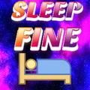

**References:**

**REFERENCE PROTOTYPE IMAGES**

[1]"Sleep Loss: 10 Surprising Effects", WebMD, 2020. [Online]. Available:

https://www.webmd.com/sleep-disorders/features/10-results-sleep-loss#1. [Accessed: 27- Mar- 2020].

[2]"54 Shocking Sleep Statistics, Data and Trends Revealed for 2020", The Sleep Advisor, 2020. [Online]. Available: https://www.sleepadvisor.org/sleep-statistics/. [Accessed: 27- Mar- 2020].

[3]"How do Sleep Trackers Work? Understand Sleep Tracking Tech", Tuck Sleep, 2020. [Online]. Available: https://www.tuck.com/how-sleep-trackers-work/. [Accessed: 27- Mar- 2020].

[4]"How Do Sleep Trackers Work And Are They Accurate?", No Sleepless Nights, 2020. [Online]. Available: https://www.nosleeplessnights.com/how-do-sleep-trackers-work/. [Accessed: 27- Mar- 2020]

[5]"The 10 best sleep apps", *Medicalnewstoday.com*, 2020. [Online]. Available: https://www.medicalnewstoday.com/articles/317816#Sleep-Cycle. [Accessed: 28- Apr- 2020].

[6]"The best Apple Watch apps we've used in 2020", *TechRadar*, 2020. [Online]. Available: https://www.techradar.com/au/news/best-apple-watch-apps-2019/2. [Accessed: 28- Apr- 2020].

[7]A. Kearney, "Why/Why don't you follow a sleep pattern?"", UQ, 2020. ""I used an app like once but i can't be bothered to check it and the medical jargon is confusing, i just wanted to know if my health was ok"

[8] H. Burford, "Why/Why don't you follow a sleep pattern?", QUT, 2020. "um, Mate i got no motivation to do that aye just too busy at the moment with assignments"

[9]"'Business 2' by ProSymbols", Iconfinder, 2020. [Online]. Available: https://www.iconfinder.com/icons/4282510/lock_security_protection_symbol_safe_shield_safety_shield_security_symbol_icon. [Accessed: 28- Apr- 2020].

[10]D. Dobbins, "Interaction Usability and Interfaces", UQ, 2020.

[11]"CDC Press Releases", *CDC*, 2020. [Online]. Available: https://www.cdc.gov/media/releases/2016/p0215-enough-sleep.html. [Accessed: 29- Apr- 2020].

[12]P. Rukiza, "Why/Why don't you follow a sleep pattern", Discord, 2020. "Yeh my sleep is so bad at the moment i just nap all day and don't sleep at night, with the sleep program I would do it but the apple watch is too expensive i can' afford something like that"

[13]A. Kearney, "Why/Why don't you follow a sleep pattern?"", UQ, 2020. ""I used an app like once but i can't be bothered to check it and the medical jargon is confusing, i just wanted to know if my health was ok"

[14]"PilotJobs | How Much Money Can Airline Pilots Really Earn?", *Pilotjobs.atpflightschool.com*, 2020. [Online]. Available: https://pilotjobs.atpflightschool.com/2015/01/23/how-much-money-can-airline-pilots-really-earn/. [Accessed: 29- Apr- 2020].

[15]"Graduate Software Engineer Salary in Australia | PayScale", *Payscale.com*, 2020. [Online]. Available: https://www.payscale.com/research/AU/Job=Graduate_Software_Engineer/Salary. [Accessed: 29- Apr- 2020].

[16]"What Is Considered a High IQ, What’s Average, What Results Mean", *Healthline*, 2020. [Online]. Available: https://www.healthline.com/health/what-is-considered-a-high-iq#what-does-an-iq-score-indicate. [Accessed: 29- Apr- 2020].

[17]"The last thing you should pack in your carry-on", *escape.com.au*, 2020. [Online]. Available: https://www.escape.com.au/travel-advice/virgin-australia-pilot-scot-williams-top-packing-tips/news-story/1209d6f3efa61a0286e0ce6685fa418a. [Accessed: 29- Apr- 2020].

[18]"Student Girl", PixalBay, 2020. [Online]. Available: https://pixabay.com. [Accessed: 29- Apr- 2020].

[19]"Coles Cashier Salaries in Australia | Indeed.com", *Au.indeed.com*, 2020. [Online]. Available: https://au.indeed.com/cmp/Coles/salaries/cashier. [Accessed: 29- Apr- 2020].

[20]"Photo by Todd Trapani on Unsplash", *Unsplash.com*, 2020. [Online]. Available: https://unsplash.com/photos/p9Vz9dyNbnU. [Accessed: 29- Apr- 2020].